2026-09-17 Srijth
Meeting 2026-09-17: uncertainty distillation (Tomasz and Srijith as profs; Sajit and Anushta as students)
Sajit reported that adding real auxiliary out-of-distribution (OOD) data to Ensemble Distribution Distillation (EnD², which distills the full spread of the ensemble members' predictions rather than just their mean, as plain EnD does) improved accuracy and OOD detection on CIFAR. Gaussian-noised in-distribution data did not work as a substitute. Anushta showed first summarisation-distillation results in which the students barely distinguish in-distribution from OOD data.
Nothing substantive was concluded. Both results were judged uninterpretable until controls and reference values exist. Both students showed gaps in understanding their own tables, flagged below.
On attribution: the diarization labels are unreliable and often merge a prof's question with a student's answer in one turn, so I assigned speakers by content. The mapping is mostly clear:
- Sajit segment: spk:0 is mainly Sajit, spk:1 mainly Srijith, spk:2 Tomasz.
- Anushta segment: spk:0 is mainly Anushta, spk:1 mainly Tomasz, spk:2 Srijith.
Sajit: EnD² with auxiliary data (CIFAR-10 in-distribution, CIFAR-100 auxiliary, and vice versa)
Sajit's claims:
- Auxiliary data reduces error from 8.3% to 7.4% and improves OOD detection. The transcript is ambiguous about whether the 8.3% refers to EnD or EnD².
- He tried about 8–10 Gaussian-noise variants and showed only the best one.
- The original paper also reports EnD ahead of EnD² on accuracy.
Srijith opened by rejecting Sajit's claim from last week that an alternative loss "didn't work". A failure needs a diagnosed cause, and Sajit has to return to it. Srijith also wanted results for multiple noise variants shown, not just the best.
Tomasz raised two points:
- Data-size confound: the auxiliary run distills on more data, so it should be compared at a matched sample count.
- Noise checked on the wrong model: has anyone measured whether the teacher ensemble is actually more uncertain on noisy inputs? He suggested learning the noise to maximise teacher disagreement as a later idea.
Red flags:
- PRR not understood. Sajit could not explain PRR (prediction rejection ratio), a metric in his own table, and admitted he "didn't go through it properly". Srijith asked twice. Tomasz's follow-up explained the OOD-detection AUROC table, not PRR, so PRR was never actually explained.
- Dataset sizes not checked. Asked for the auxiliary-to-in-distribution ratio, Sajit gave only dataset names, then agreed with Srijith that the auxiliary set is "much larger". CIFAR-10 and CIFAR-100 have the same training size (50k each), so this looks unverified.
- Evasive on the teacher question. Asked about teacher uncertainty on noise, he answered with student results instead (AUROC 96 for total uncertainty, 98 for knowledge uncertainty on the EnD² student). When pressed, he gave a garbled non-answer. He has no teacher numbers.
- Unverified paper claim. His statement that the paper also shows EnD beating EnD² on accuracy is plausible but should be checked against the paper's table.
Anushta: summarisation distillation
Setup:
- Data: SAMSum as in-distribution; DialogSum and word-shuffled SAMSum as shifted sets.
- Teacher: Mistral-7B-Instruct with four prompt templates.
- Uncertainty: token-level (product of expectations) and sequence-level (expectation of products).
- Students: Softmax, Dirichlet and Laplace, trained on 1,500 samples for four epochs.
Srijith's interpretation was that DialogSum is too similar to SAMSum to be detected, while shuffled text looks clearly OOD.
Tomasz's observations:
- DialogSum AUROCs are below 0.5, i.e. worse than random.
- The Softmax student shows only a small increase in uncertainty on DialogSum, and the Dirichlet and Laplace students are flat (4.46 to 4.47).
- The large in-distribution gap between Softmax and Laplace is suspicious.
- Without reference values, the table may be noise.
Red flags:
- Unlabelled tables. She presented student scores as "raw uncertainty scores" without saying they came from students; Tomasz had to ask.
- No teacher reference ready. When asked for teacher reference values, she had to fetch them from another machine. Later, when Srijith asked whether a table showed teacher or student values, she said she needs to check. She is unclear what her own tables show.
- Overclaimed signal. She claimed the teacher picks up the DialogSum shift and suggested a threshold above 0.5, which conflicts with the below-chance AUROCs.
- Weak convergence evidence. Her claim that the students converged rests only on watching the loss, and she did no hyperparameter tuning.
- Unsupported "rule". She cited a supposed rule from papers that Dirichlet students show higher epistemic and Laplace students higher aleatoric uncertainty under shift. Tomasz said he knows of no such rule. At the end she fell back on another unsupported claim, that Laplace usually works better for generation.
- Missing table. An oracle/rejection-based table she mentioned (garbled in the transcript as "EURSE") was not shown.
Next steps
Sajit:
- Compute teacher-ensemble uncertainty (total and knowledge) on in-distribution, auxiliary and noisy data. Tomasz asked for this and Srijith confirmed it.
- Rerun EnD² vs EnD²+auxiliary with the number of distillation samples matched. Tomasz proposed this and Sajit agreed.
- Return to the failed loss experiment and diagnose it (Srijith). Implied, not explicitly assigned: understand PRR and report all noise variants.
- Later, possibly: learned noise that maximises teacher disagreement (an idea from Tomasz, not assigned).
Anushta, for the next meeting:
- Teacher reference scores for the same table.
- Scores from untrained students as a baseline.
- Hyperparameter tuning of the students.
- Clarify which of her tables are teacher values and which are student values.
The table will be reinterpreted once these references exist; no model will be selected before then.

2026-09-10 Srijth

Sajid Ali [9:54 AM]
Summary of what i presented in the meeting:
We followed the Ensemble Distribution Distillation paper (arXiv:1905.00076).
- Teacher training: Trained an ensemble of models independently using standard cross-entropy loss.
- Distillation (EnD²): Built a transfer dataset by passing each training input through all teacher members to collect their categorical predictions. The student is trained on these inputs, learning to fit a Dirichlet distribution over the teacher categoricals via an NLL loss. Up to this point, our results matched the paper.
- OOD extension (our attempt): We tried explicitly training the student on OOD samples using a reverse-KL loss toward a uniform (flat) target Dirichlet. This did not improve OOD detection, it degraded in-domain classification performance instead.
- What the paper actually does differently: Rather than using a fixed flat target for OOD, the paper first passes the OOD samples through the (ID-trained) teacher ensemble as well (creates the transfer dataset for training OOD samples ), obtaining diverse teacher categoricals on OOD inputs (since the teacher wasn't trained on OOD data, its members naturally disagree there). The student then learns a Dirichlet from these diverse OOD categoricals, the flatness emerges from teacher disagreement, rather than being imposed as a fixed uniform target.

Next step: Re-run the OOD experiment following the paper's actual approach — pass OOD samples through the ID-trained teacher ensemble to get diverse teacher categoricals (instead of a fixed flat target). Also test the noise-as-proxy-OOD setup, where noise-perturbed ID samples (rather than a separate OOD dataset) are passed through the teacher, and check whether this noise signal improves OOD detection.

==========================

THE BELOW DID NOT MAKE MUCH SENSE (APART FROM MAYBE THE FIRST 2 LINES OF RESULTS):

Anushtha Tamrakar [1:53 PM]
Please have a look into the results and let me know what do you think.

Table 1 - Uncertainty Values
Method | Softmax | Total-Dirichlet | Epistemic-Dirichlet | Aleatoric-Dirichlet | Total-Laplace | Epistemic-Laplace | Aleatoric-Laplace
PrEx | 0.9173 | 4.4578 | 0.1114 | 4.3465 | 5.6860 | 0.8142 | 4.8718
ExPr | 0.8596 | 4.4679 | 0.1133 | 4.3546 | 5.8569 | 0.8204 | 5.0365

Table 2 - OOD detection
| Model |Total-AUROC-DialogSum | Epi-AUROC-DialogSum | Ale-AUROC-DialogSum | Total-AUROC-Shuffled | Epi-AUROC-Shuffled | Ale-AUROC-Shuffled
|-----------------|-----------------------------|------------------------------|-----------------------------|----------------------------|---------------------------|--------------------------
| Softmax-PrEx | 0.5100 | — | — |0.8100 | | —
| Softmax-ExPr | 0.5400 | — | — |0.7900 | | —
| Dirichlet-PrEx | 0.4000 | 0.5700 | 0.3800 | 0.6900 | 0.3000 | 0.6800
| Dirichlet-ExPr | 0.3900 | 0.5400 | 0.3400 | 0.5900 | 0.2900 | 0.6400
| Laplace-PrEx | 0.5600 | 0.7400 | 0.4900 | 0.7600 | 0.5500 | 0.7800
| Laplace-ExPr | 0.5500 | 0.5500 | 0.5800 | 0.8100 | 0.5600 | 0.8200

Table 3 - ROUGE Score
| Student | ROUGE-1 | ROUGE-2 | ROUGE-L
|-----------------|------------| ------------|-------------
| Softmax-PrEx | 0.4118 | 0.0804 | 0.2859
| Softmax-ExPr | 0.4071 | 0.0915 | 0.2870
| Dirichlet-PrEx | 0.2820 | 0.0660 | 0.1904
| Dirichlet-ExPr | 0.3580 | 0.0884 | 0.2207
| Laplace-PrEx | 0.4118 | 0.0804 | 0.2859
| Laplace-ExPr | 0.4071 | 0.0915 | 0.2870 (edited)

2026-09-03 Srijth

The meeting had two halves. The first was a literature check on a question carried over from the previous session: Prior Networks (Malinin & Gales, 2018) trains its Dirichlet head with an explicit out-of-distribution term in the loss (Eq. 12), but the follow-up Ensemble Distribution Distillation paper (EnD², 2019) dropped that term, and the group wanted to know whether anyone had since put it back. Tomasz and Srijith went through four candidates — Wang et al. (2024) on Bayesian networks meeting evidential deep learning, Fathullah et al. (2023) on logit-based EnD², Ryabinin et al. (2021) on Proxy-EnD², and Fathullah & Gales (2022) on self-distribution distillation — and concluded that none of them uses OOD or noisy data in the training objective. The gap is therefore open and the group's proposal stands.
The second half turned that into a work plan. The agreed base is the 2019 EnD² paper: obtain the authors' code or reimplement it, then add an OOD-based auxiliary distillation loss, tried with both explicit OOD data and noised in-distribution data. Before any of that, Tomasz raised the preliminary experiment they had planned, and it was confirmed as the first task: measure the teacher's entropy on clean in-distribution text, on noised versions at several noise levels, and on genuine OOD text, to establish whether noise is a usable OOD proxy at all. That is Tomasz's job, due this weekend and posted to Slack. Anushta reported in parallel on her prompt-ensemble setup, results due within a day or two. The next meeting will be short or skipped, since Tomasz is at ESMR.
On the survey. Srijith's framing was that the 2019 omission is suspicious on its face: the paper inherited the Dirichlet head but not the OOD term, so it is natural to ask both why, and whether a later paper reintroduced it. The students' initial Google search found nothing, which he judged insufficient. Of the four papers reviewed, Wang et al. (2024) got the most attention — its Eq. 6/7 combine a MAP objective (the standard classifier loss) with a KL regularizer on the Dirichlet head and a post-hoc adjustment of the evidence mass α₀. Tomasz connected it to earlier discussions with Harsha around Laplace approximations and normalizing flows that were never carried out; both agreed it is a modern route to Dirichlet-head distillation but uses neither OOD nor noisy data. Fathullah et al. (2023) replaces Dirichlet outputs with logit-space modelling for autoregressive sequences and uses OOD only at evaluation time. Ryabinin et al. (2021), surfaced by Srijith's LLM search as the closest hit, contributes sequential distillation and a reverse- rather than forward-KL objective. Fathullah & Gales (2022) trains parts of the teacher during distillation, on image data — Tomasz called it interesting but going in a different direction entirely.
One caveat is worth carrying forward. The text Srijith pasted into the chat was LLM output, not extracted from the papers, and it credits Ryabinin et al. with "structured auxiliary sampling" and Fathullah et al. with "auxiliary off-manifold sampling". Neither claim was confirmed by Tomasz's reading. If either turned out to be accurate it would undercut the novelty argument, so it should be checked against the actual texts. Nobody was assigned this.
On Anushta's track. She is building the simplest configuration: a Bayesian teacher and three students with softmax, Dirichlet, and Laplace-distribution heads. The teacher is a Bayesian prompt ensemble following Harsha's method rather than Aviraj's — three summarization prompts with learned weights currently around 0.67, 0.05 and 0.35. SAMSum is the in-distribution summarization set, DialogSum the OOD set, and noise is introduced by shuffling words within SAMSum inputs, which she flagged as the easiest option and open to refinement. Only ROUGE is computed so far. PRR (prediction rejection ratio) is understood but not implemented, calibration metrics are unresolved, and she noted that token-level uncertainty suits dialogue summarization while sequence-level matters more for translation-type tasks.
Tomasz, who lost audio during this stretch and had Srijith recap it, questioned whether DialogSum is sufficiently out-of-distribution. Srijith's answer was that both are dialogue summarization but the domains and typical input lengths differ substantially — one being short conversational exchanges, the other much longer — which is what Aviraj had reported, citing a paper using the same pairing. Neither could recall which dataset was which or which paper it was. Tomasz suggested adding a further OOD dataset later; the pairing was accepted provisionally for now. Srijith's instruction on metrics was to compute both product-of-expectations and expectation-of-product aggregations. A previously discussed paper concluded the former models uncertainty better, but since the comparison here is between datasets rather than between metrics, reporting both is fine. He stressed these are not the main results, only the basis for deciding what comes next.
One reading note. The transcript's speaker labels are unreliable — whole blocks of Srijith's speech are tagged as Tomasz — and several terms are garbled: "auto distillation loss" and "audio loss term" both mean OOD loss, "Proxy IND square" is Proxy-EnD², "logic-based" is logit-based, "Samsung" is SAMSum, "Riyabinin" is Ryabinin, and "prompt assembling" is prompt ensembling.
================================================================

From Srijth: From LLM:
Scaling and Auxiliary Targets ($\text{Proxy-EnD}^2$): Ryabinin et al. (2021) analyzed convergence failures in $\text{EnD}^2$ on large class spaces and introduced proxy-target formulations alongside structured auxiliary sampling to stabilize epistemic uncertainty outside the primary class boundaries.Sequence-Level OOD Distillation: Fathullah et al. (2023) extended ensemble distribution distillation to autoregressive sequence models, incorporating auxiliary off-manifold sampling and logit-based regularization to prevent student models from producing overconfident estimates on out-of-domain text sequences.

- Fathullah, Y., Xia, G., & Gales, M. (2023). Logit-Based Ensemble Distribution Distillation for Robust Autoregressive Sequence Uncertainties. arXiv. https://doi.org/10.48550/arxiv.2305.10384
- Ryabinin, M., Malinin, A., & Gales, M. (2021). Scaling Ensemble Distribution Distillation to Many Classes with Proxy Targets. arXiv. https://doi.org/10.48550/arxiv.2105.06987
Cited by: 31

One more paper from Gales:
- Fathullah, Y., & Gales, M. J. F. (2022). Self-Distribution Distillation: Efficient Uncertainty Estimation. arXiv. https://doi.org/10.48550/arxiv.2203.08295

https://proceedings.mlr.press/v244/wang24g.html

2026-08-20 (Anushta)

We have been exploring:
- malinin (https://arxiv.org/pdf/1802.10501) Eq. 12 :
- separate term for OOD -> when you have this term you have to have uniform distribution of

FIrst paper doing Evidential distillation: https://arxiv.org/pdf/1905.00076

- > THEY USED OOD for learning in https://arxiv.org/pdf/1802.10501 but not for distillation in https://arxiv.org/pdf/1905.00076

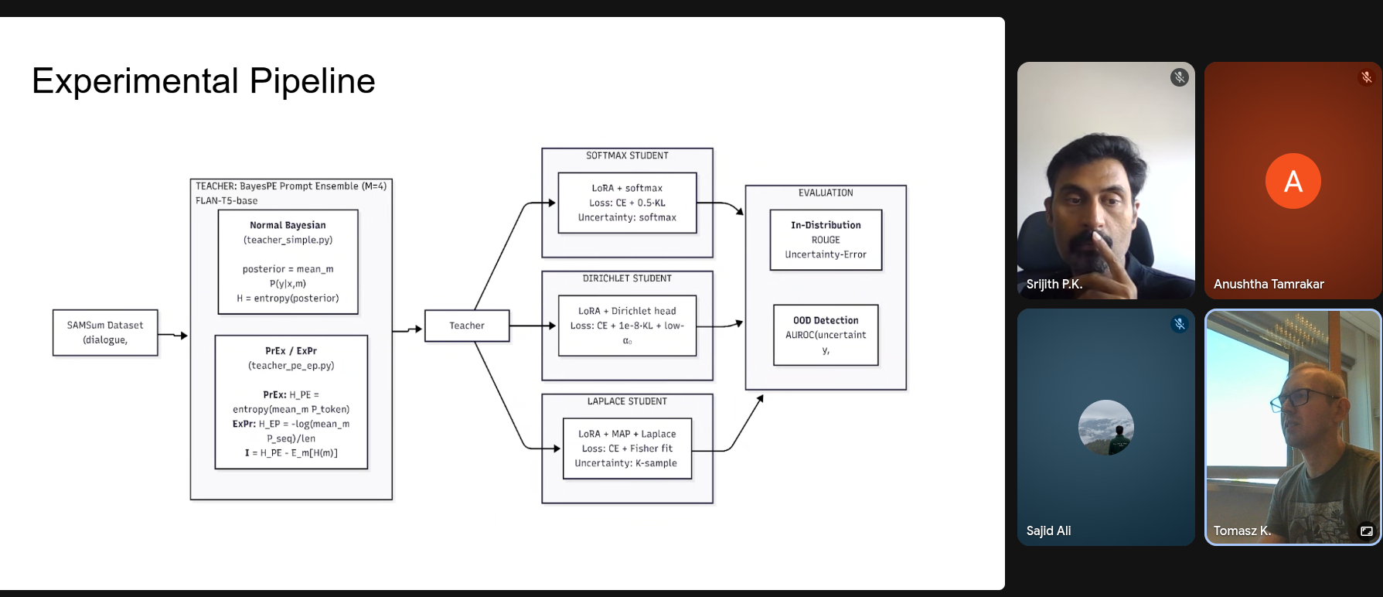
The below two are highly confusing…
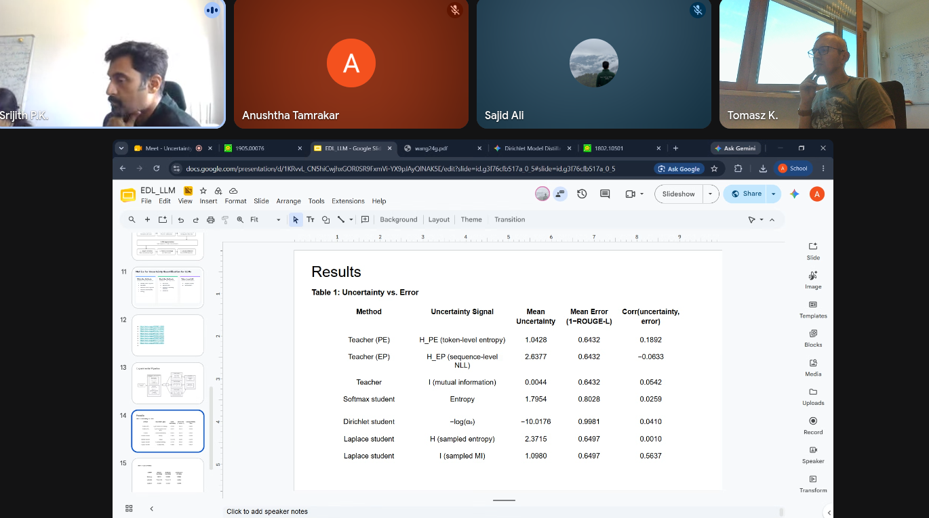
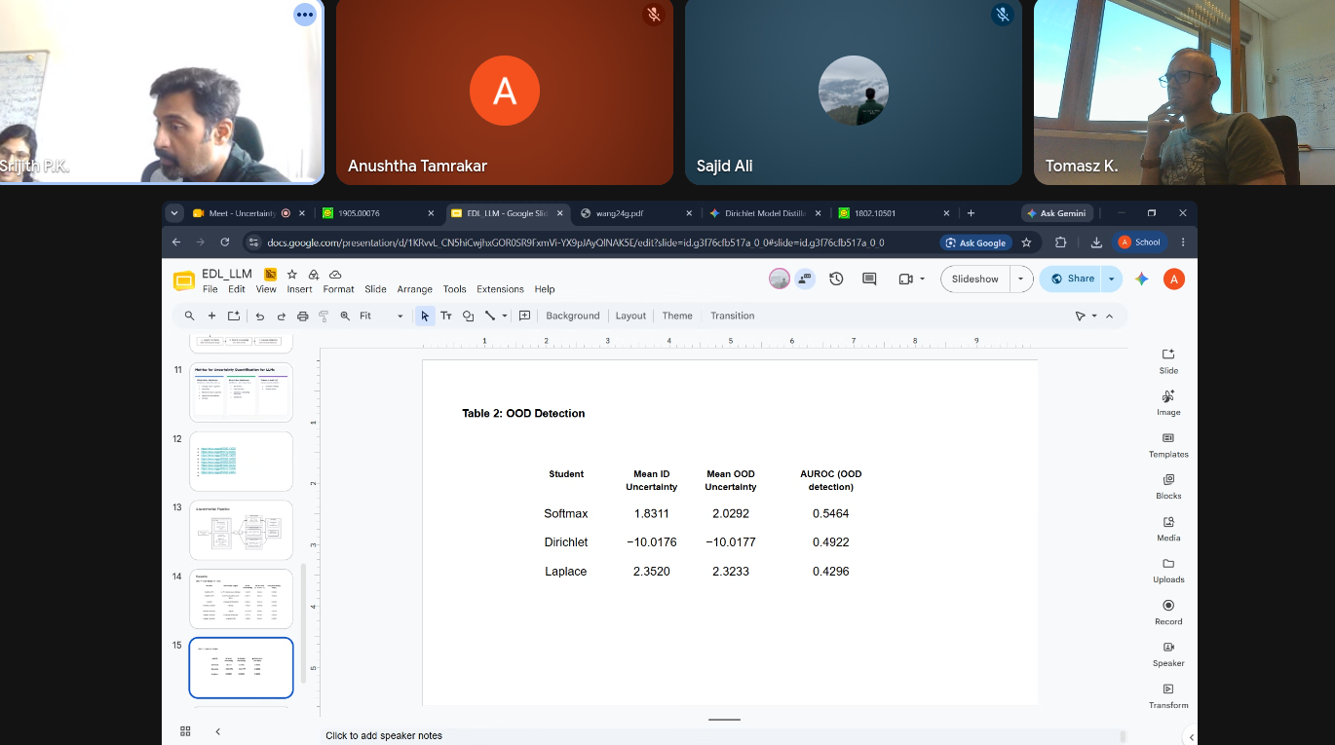

2026-08-13

- check by generation from multiple models
- continue about Laplace direction from Harsha

second direction:
- one direction UQ in LLMs
- standard deep learning models (Sajid Ali)
  - reproduce Evidential Deep Learning results from: Evidential Deep Learning to Quantify Classification Uncertainty
  - he did: what happens what if we train on noisy data as well (his own initiative)
    - they did use laplace

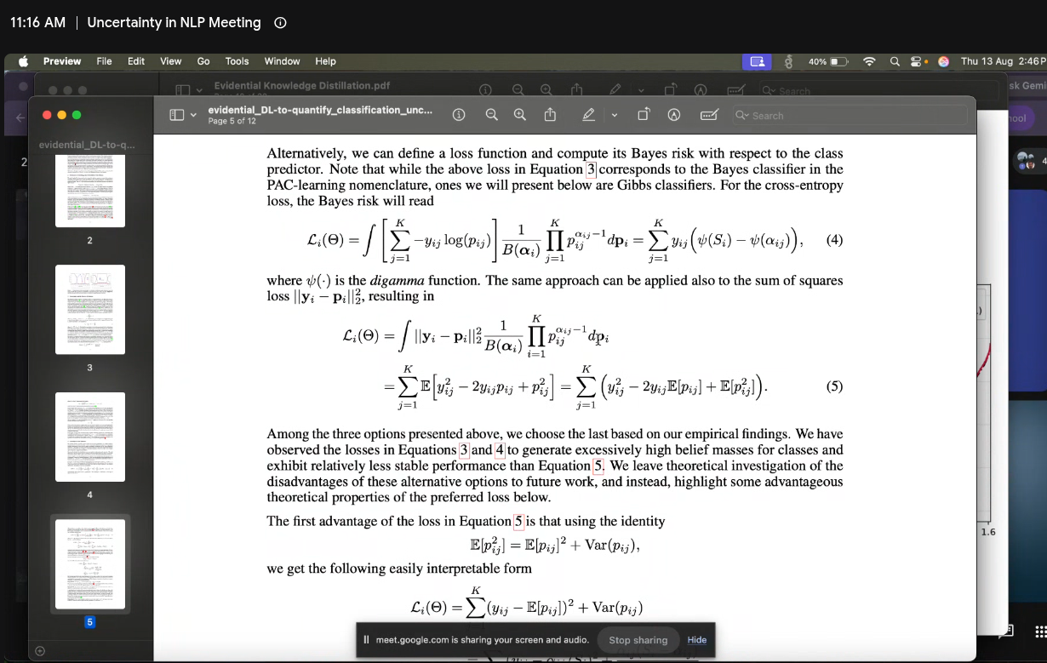
  - 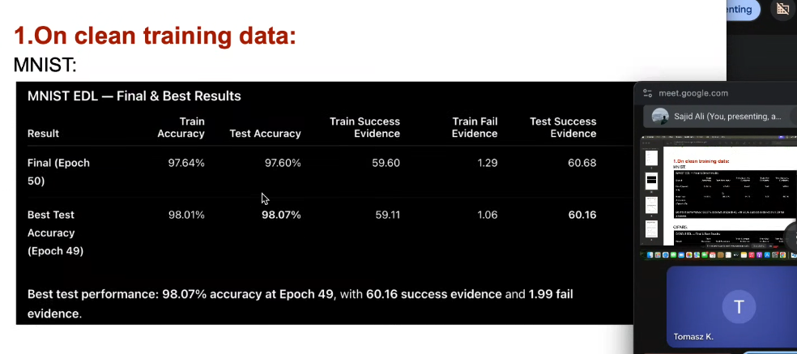
- 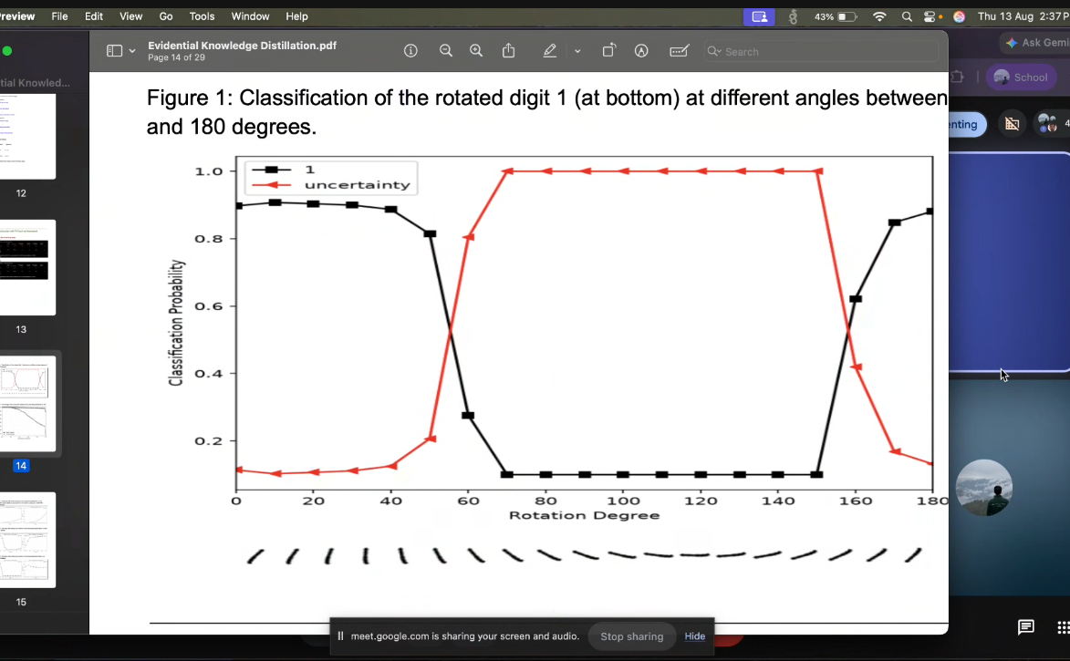
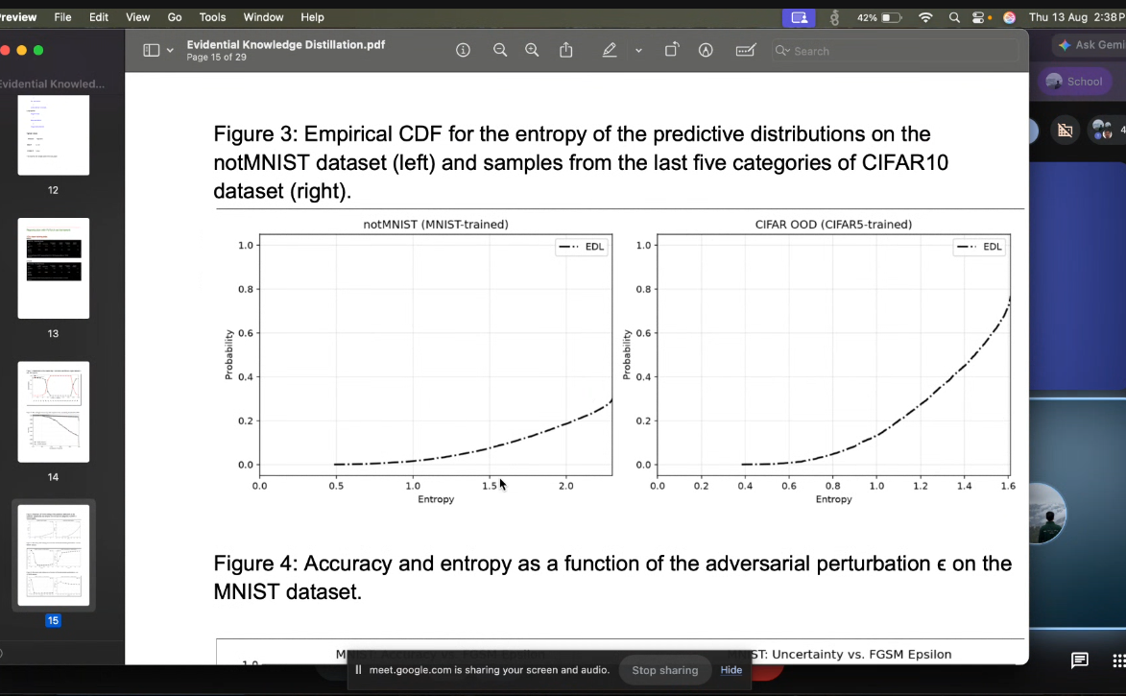

tried: gaussian noise, salt and peper noise

model becomes uncertain about noisy samples:
OOD results for EDL model or EDL model trained with noisy data
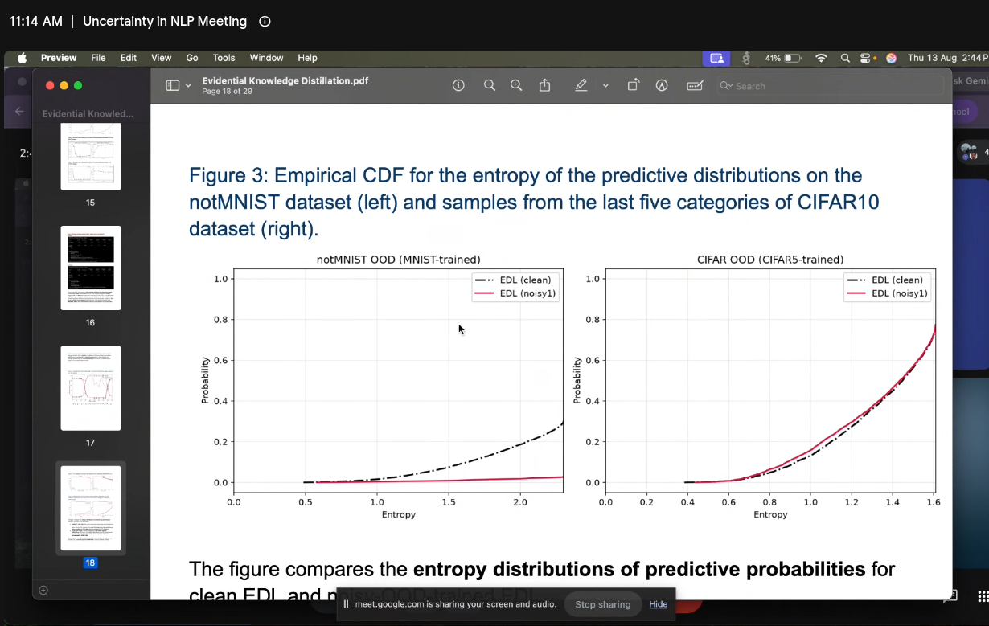
THE PLOT IS FUCKED UP!

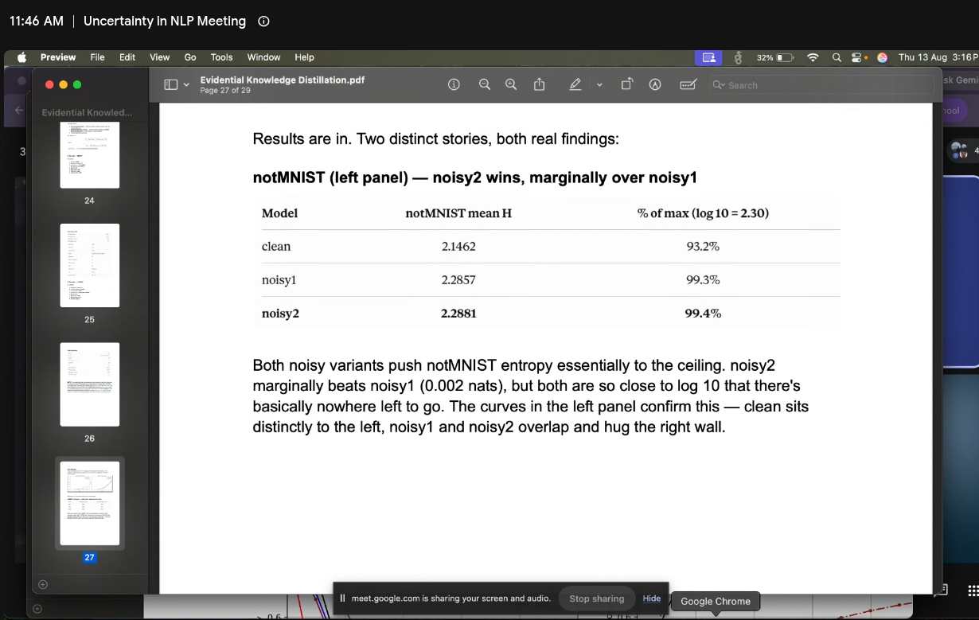
2026-07-23 Srijth

- test na zadaniach LLM (generative / klasyfikacja) i resnet że Noisy (=OOD) data daje niepewność
- dla zadań klasyfikacji niepewność jest jasna TU=EU+AU. dla generacji weźmiemy: https://openreview.net/pdf?id=jN5y-zb5Q7m (Mailinin + Gales)

2026-07-16 Srijth
Meeting Notes [16/07/2026]:
- Read and understand the mathematical derivations presented in the paper [https://arxiv.org/pdf/2305.19187], with particular emphasis on the probabilistic formulation and uncertainty estimation framework.
- Investigate the theoretical significance of Expectation of Product and Product of Expectations, and explore how these formulations can be leveraged in probabilistic knowledge distillation to effectively transfer uncertainty from the teacher model to the student model.
- Conduct a literature survey on uncertainty estimation metrics commonly used in Natural Language Generation (NLG) tasks, and analyze their applicability for evaluating uncertainty in generative models.
- Explore methods for incorporating uncertainty metrics into the proposed knowledge distillation framework to improve uncertainty preservation, calibration, and the reliability of the student model's predictions.

2026-06-25

- Think/literature review: how to measure and decompose uncertainty for or Bayesian generative models? A possible approach: identify how to measure uncertainty measures for generative tasks -> think how to aggregate/apply it for Bayesian learning where each weights sample is a separate model.
- There are problems with Evidential learning for large number of classes. We could consider different heads (e.g. what heads can be useful for distillation?) vs learning method (a NeurIPS paper under revision suggests that Dirichlet is enough if the right training is used). We also talked about correlated topic models in heads.
- Things to verify: does the low epistemic uncertainty (for distillation) issue happens also for other deep learning models
- We would like to find out if adding noisy text inputs help with distillation. First step is to validate that (teacher) models less certain on noisy data. Perhaps we should start with Harsha’s code where in the text-classification setting uncertainty can be measured easily.

2026-05-14: Srijth

coupleof paper si found for review at neurips related to evidential KD .. trying to address soem of its drawbacks
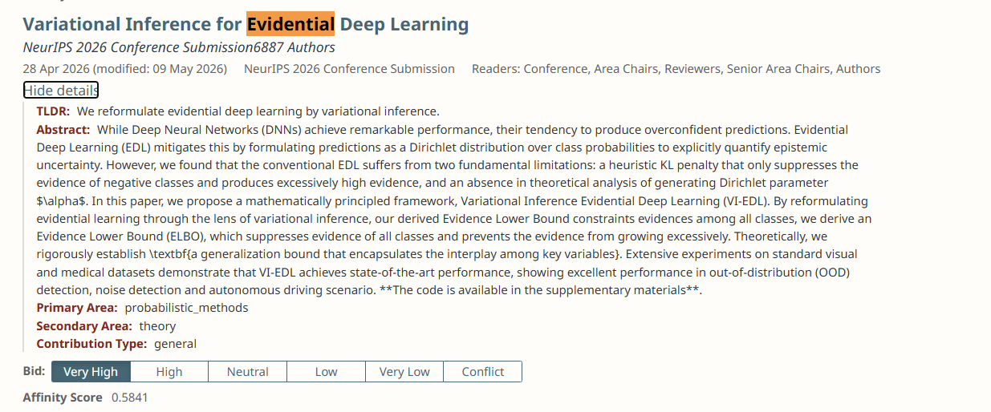
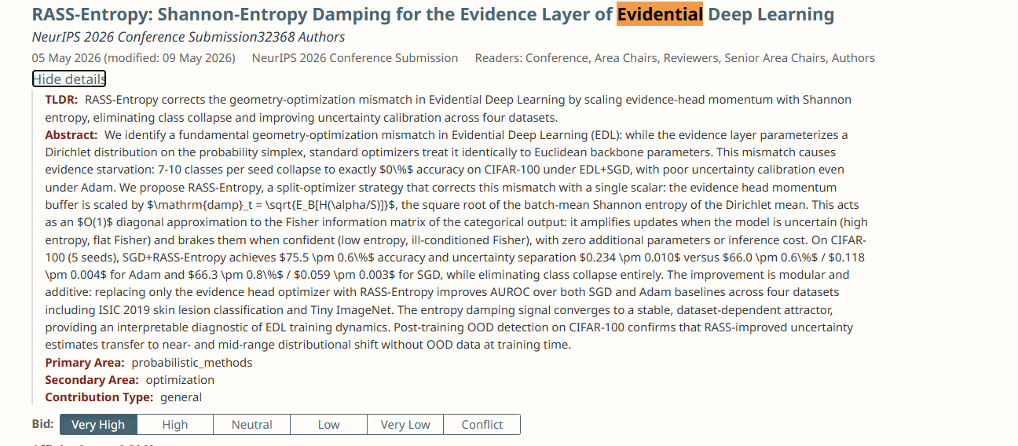
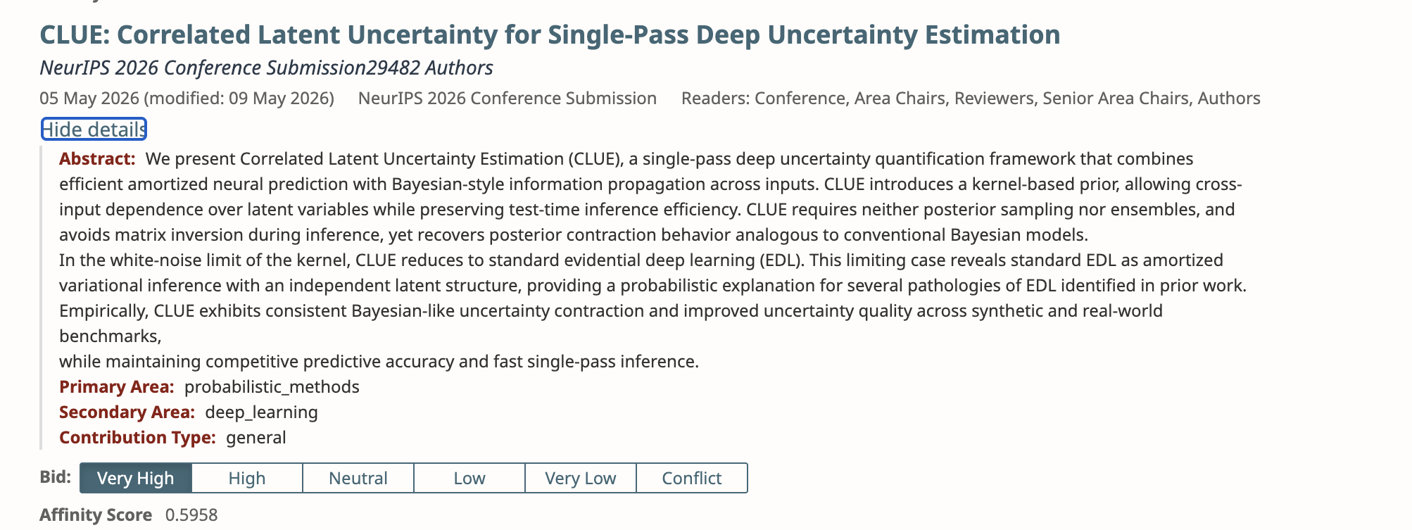
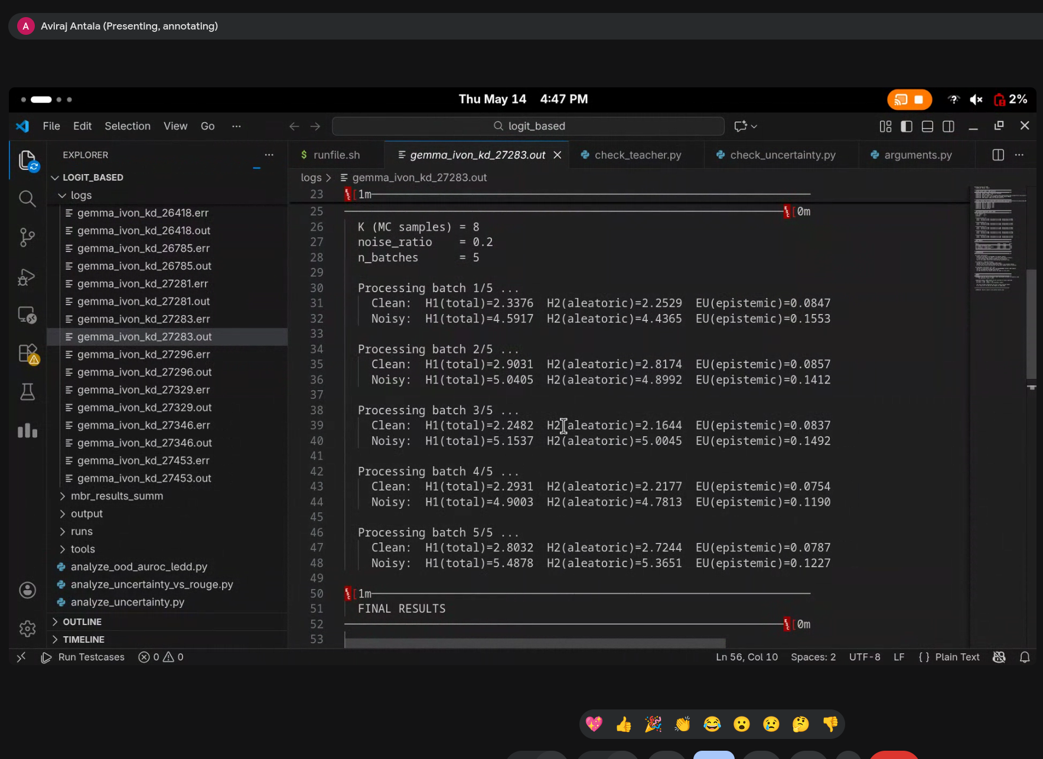

2026-05-12: LLM Priors

Aviraj Antala 6:06 PM
Hello sir, I checked the uncertainty for the teacher as we discussed in the meeting, to verify whether the teacher itself becomes more uncertain on noisy/corrupted inputs. I got the following results:
- Clean H1 (Total Uncertainty): 2.52 nats → Noisy: 5.03 nats (2.00x)
- Clean H2 (Aleatoric Uncertainty): 2.44 nats → Noisy: 4.90 nats (2.01x)
- Clean EU (Epistemic Uncertainty): 0.08 nats → Noisy: 0.14 nats (1.68x)

model can not capture uncertainty about whole sentences ?

Hello sir, I went through the literature for the noise addition technique we are using in the code. I found that two standard papers are doing something very similar.

First is the BERT paper (Devlin et al., 2019), in their masked language model pretraining they select 15% of tokens and out of those 10% are replaced with a completely random vocabulary token. This is exactly what our code is doing — picking random positions and replacing them with random tokens from the vocab.

Second is the BART paper (Lewis et al., 2020), they introduce token shuffling as one of their noise strategies where they randomly shuffle the order of tokens in the input as a corruption technique. Our code does a softer version of this — instead of shuffling the whole sequence we shuffle within a small local window of 8 tokens around the selected position.

2026-03-12 Srijith:
i got a relevant paper omn uncertainty aware knowledge distillation for review from KDD 2026..

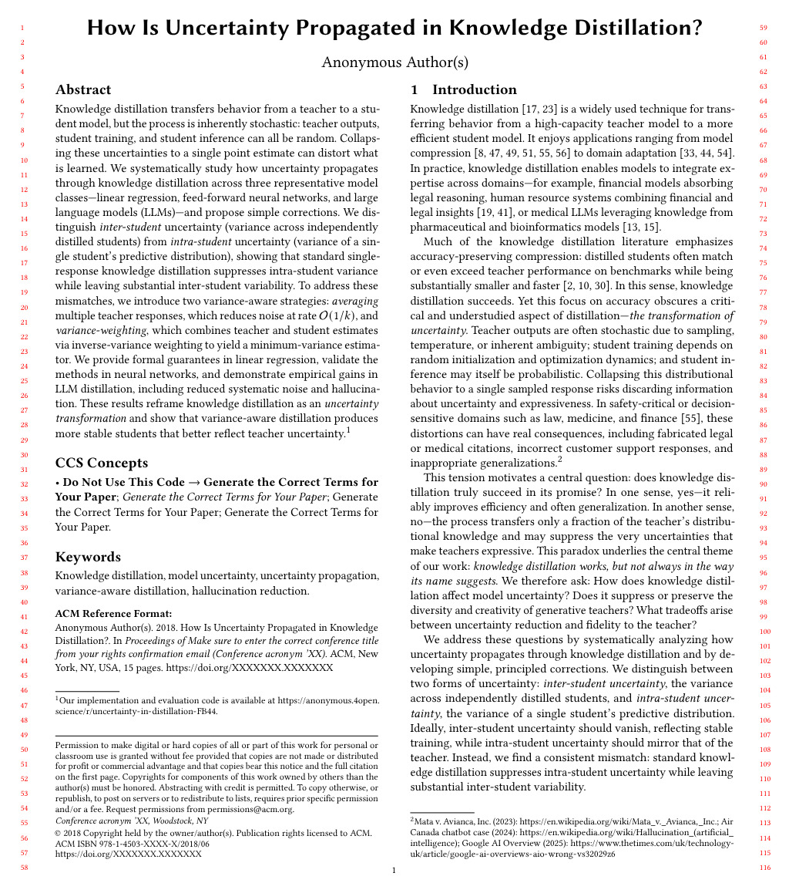
Aviraj Antala [12:09 PM]
https://arxiv.org/pdf/2305.10384

srijith [9:31 PM]
Hi Aviraj, can you share here teh point we discussed in the last meeting . Here is one work which seems close to one point (making EDA uncertainty aware using additional noisy/OOD data) we discussed last meeting https://dl.acm.org/doi/10.5555/3692070.3694431.
https://www.sciencedirect.com/science/article/pii/S1071581925000126
Confronting verbalized uncertainty: Understanding how LLM’s verbalized uncertainty influences users in AI-assisted decision-making

2026-03-26: LLM Priors

- Push ID and OOD data through: teacher, softmax student and laplace student
- Record Total Uncertainty (predictive entropy) and Epistemic Uncertainty (predictive IM; except for softmax student) for each row
- Plot distributions per model per dataset
- Compute averages per model per dataset
- Compute AUROC by comparing TU and EU scores from ID and OOD for each of the models

How to go with the https://arxiv.org/pdf/2305.10384

- my idea: regularization on sigmas of the Laplace output?
- Srjith: Distillation from Multiple teacher models?
  - how to take into account uncertainty for learning: Eq.11 is using sigma for students -> can we use something like that for teachers
  - when doing distillation can take into account this uncertain
  - RQ: if we had students with various sigmas - would it be able to learn uncertainty or just copy the strongest/most-confident
  - which teacher should give confidence for a specific task (??? MOE??)
  - TODO: What should be the loss?

2026-03-19: LLM Priors

@Harsha
- could you please rerun the above experiment for OOD with Amazon vs SST2 datasets to check if we get the same results?
- would you be able to run the following baseline: train (=fine-tune) students directly on training data using cross-entropy loss?

https://arxiv.org/pdf/2305.10384

srijith@cse.iith.ac.in

i got a relevant paper omn uncertainty aware knowledge distillation for review from KDD 2026..
How Is Uncertainty Propagated in Knowledge Distillation?

https://www.sciencedirect.com/science/article/pii/S1071581925000126
Confronting verbalized uncertainty: Understanding how LLM’s verbalized uncertainty influences users in AI-assisted decision-making

[PDF] Detecting Misbehaviors of Large Vision-Language Models by Evidential Uncertainty Quantification
T Huang, R Wang, X Liu, Y Qin, L Duan, L Jing - arXiv preprint arXiv:2602.05535, 2026
Large vision-language models (LVLMs) have shown substantial advances in
multimodal understanding and generation. However, when presented with
incompetent or adversarial inputs, they frequently produce unreliable or even …

2026-03-12: LLM Priors
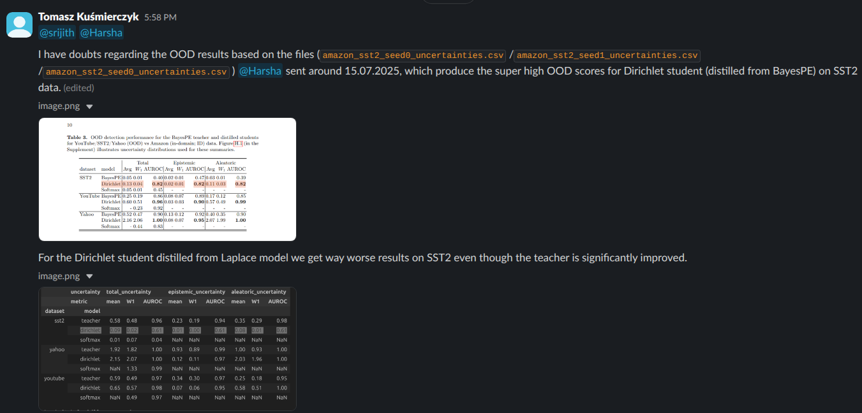
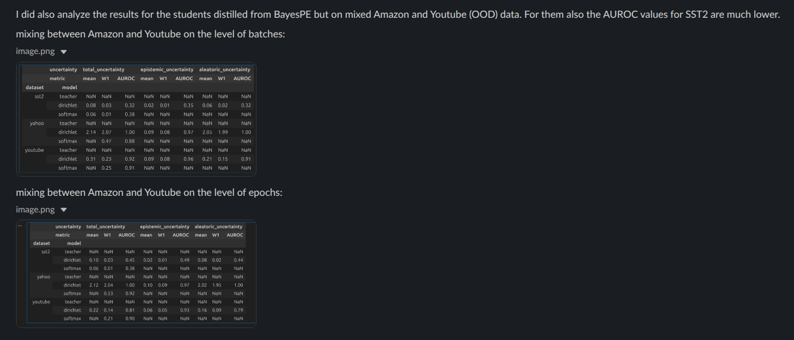

2026-02-14: LLM Priors (Harsha)
The idea for improving uncertainty by distilling on training data + OOD (training) subset mixed.
- We train a teacher on amazon training subset
- We get predictions for amazon training subset + youtube (OOD) training subset
- We distill student on these mixed predictions from the teacher. Let's consider two strategies:
  - one batch from amazon then one batch from youtube then one from amazon and so on
  - one epoch from amazon, then one epoch from youtube, then one from amazon and so on
- Evaluate ACC, NLL, Brier, ECE on Amazon and Youtube
- Get uncertainty (entropy) scores for Amazon, Youtube, Yahoo, SST-2
- @Harsha makes sense?

2026-02-07: LLM Priors (Harsha)
For results with eps+softplus: for some datasets they seem to differ from the results for 1+softplus, but it is hard to say just by looking on spreadsheets how much. we will run for 2 more seeds (but fewer epochs to save compute as they usually converge in lesst than 20-30 epochs) and then we can simulate early stopping and compare means and stds.

For softmax the OOD scores change between after few epochs vs after 50 epochs, even though the metrics for in-doman data suggest we are converged after few epochs. The changes are how ever the largest for yahoo dataset which has 10 classes (!). For the other datasets it is not clear if the differences are meaningful e.g. do they change the picture much. We need to think a bit more about that.

We will run for 50 epochs for Dirichlet student.

2026-02-05: LLM Priors

- On Saturday we will meet to discuss with Harsha the results:
regarding using alpha=epsilon+softplus instead of alpha=1+softplus
regarding softmax student trained for longer
- We need to review literature regarding evaluation of uncertainty in generative tasks. Candidates to take a look:
- MAUVE Scores for Generative Models: Theory and Practice

- Cleanse: Uncertainty Estimation Approach Using Clustering-based Semantic Consistency in LLMs

- Towards Uncertainty Quantification in Generative Model Learning

- https://arxiv.org/pdf/2601.18909

- https://arxiv.org/pdf/2403.12636

3. Let's think about "Depth uncertainty in neural networks" - can this framework be used to model uncertainty in LLMs in a single-pass ?

2026-01-29: LLM Priors
We need to think how to evaluate uncertainty in generative modeling.

2026-01-12: LLM Priors - IJCAI Submission
- TODO: Currently we do alpha = 1 + softplus(logit). We should validate what happens with alpha = epsilon (1e-8) + softplus (logit)
- We have commented out OOD results for Laplace teacher
- TODO: Move Section 4.1 to Supplement
- We have not touched results newer than 2026-01-13

Literature review:
- Efficient Uncertainty Estimation via Distillation of Bayesian Large Language Models
- Bayesian Knowledge Distillation: A Bayesian Perspective of Distillation with Uncertainty Quantification
- Training-Free Bayesianization for Low-Rank Adapters of Large Language Models
- Beyond Dirichlet-based Models: When Bayesian Neural Networks Meet Evidential Deep Learning
- Decomposing Uncertainty for Large Language Models through Input Clarification Ensembling
- Evidential Deep Learning to Quantify Classification Uncertainty

2026-01-12: LLM Priors - Aviraj
We’ve looked on samples’ (4 samples) next token predictions. For example, for the first token “Mark” we see next usually “Alice” with probs 0.42, 0.51, etc.

We use SamSum dataset
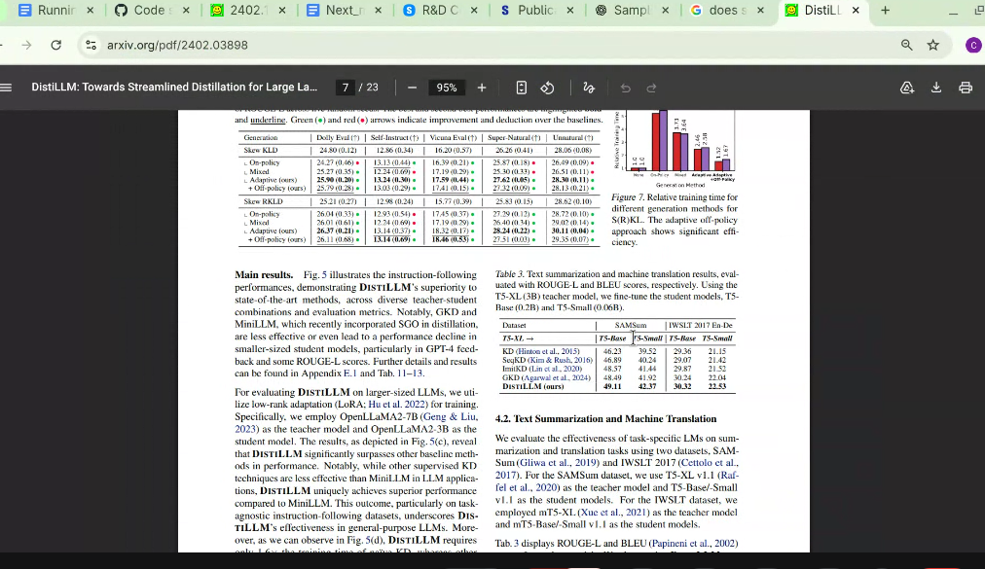

but for the previously distilled model (on means of the predictions) we got
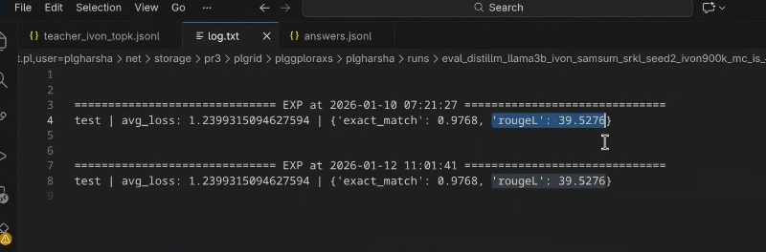

We will train models using separate loss terms for each token.
Then we will try with Dirichlet outputs.

TODO How to measure uncertainty? Rouge-L dosent do that.

2026-01-08: LLM Priors - Aviraj
From what I understand we managed to get the teacher's posterior (means+variances) using IVON and then, we can sample probability distribution for tokens from the posterior predictive distributions. Correct?
Let’s then export to a file the predictive probabilities for teacher samples for the training sequences, so we could take a look at them.

From what I understood, we managed to run the DistillLLM code for distilling students (using LoRA (?)) for averages of the teacher’s token predictive probabilities, i.e., we averaged the samples from the teachers and then used them as ground truth for the distillation loss. Correct? This didn’t work well, right?

Then, what we should do is to consider each teacher sample separately e.g. compute the distillation loss for each sample separately and then add (or average) them. Instead of taking the average of samples we would take the average of loss values for samples. Is it clear?

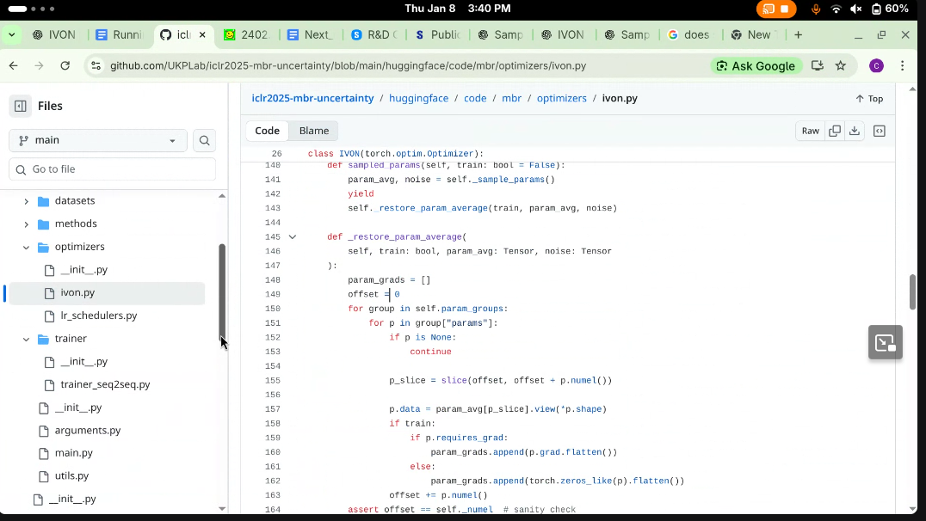
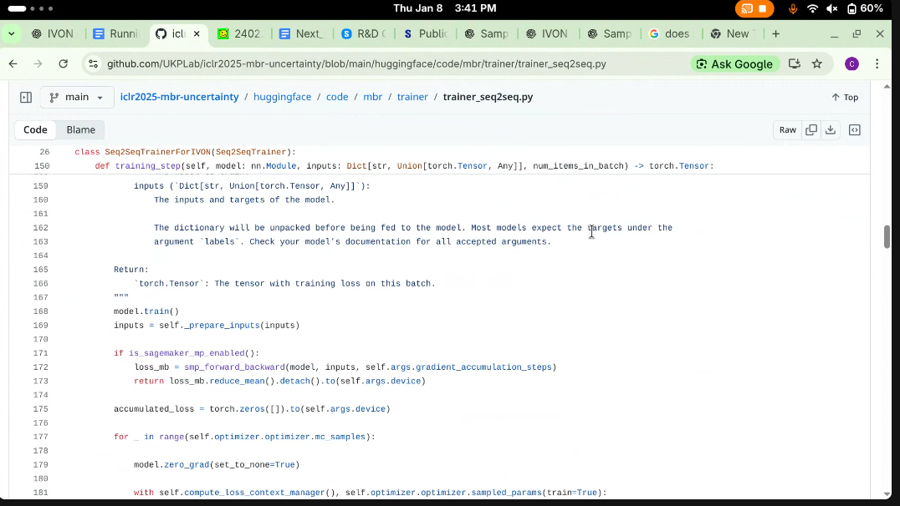
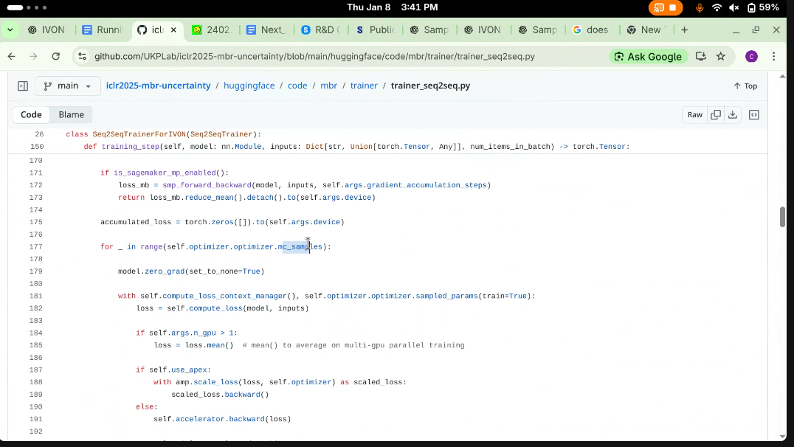
Sampling:
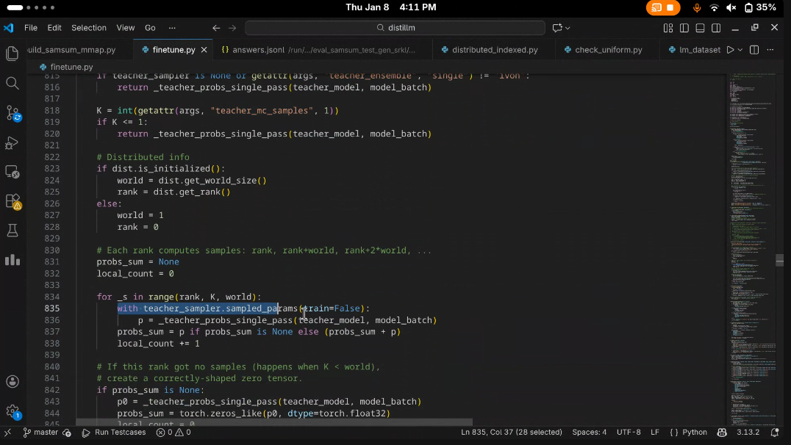

Previous:

1. There are two sources of variability in MBR models: A. due to random initialization of the models; B. due to sampling from posterior by IVON. Currently, we do know how to only use the former one. At training we simply train K=3 different models. At inference we generate responses by using averaged predictions from K=3 models.

mistral model
3 teachers -> on inference we generate sentence from averages of probabilities
we did distill llm on avearege probs, now we do on average of DKLs
then on DIrichlet losses

2026-01-07: LLM Priors
Notes:
1. Differences (test NLL, ECE, Acc, Brier) between methods are tiny: for final reporting we need averages over multiple runs
2. Laplace teachers: we saved checkpoints from MAP (1st phase: *.py files), but we are not sure about 2nd phase (fitting Hessians: *_laplace.py files). We have saved 10k predictive samples for a teacher model fine-tuned on each dataset. For now we commented out the code for saving (e.g. `torch.save(all_teacher_samples, teacher_path)`). We used the defaults from the `Laplace Lora` py files: kron-approximated Hessians, GLMs, Gaussian approximation of predictive logits distributions, etc.

TODO:
1. Let's train Dirichlet student for Amazon data with lr=1e-5 and fixed alpha0 = 10.
2. Let's train Dirichlet student with learnable alpha0 (beta=1.) for Amazon and Yahoo with alpha0_lr = 1e-2.
3. Refactor: create a common.py for functions, classes and repeated code from LoRA students.
4. Refactor: clean up llm_model_modified_Copy1.py/llm_model_modified_Copy2.py/llm_model_modified1.py/llm_model_modified.py so there is just a single file
Plan:
1. When we have the above results we will run evaluation for 3 different seeds (e.g. for 2 more) and create a final reporting table with means +/- std.
2. Then we will run OOD experiment for ID=Amazon and OOD=other datasets for the Softmax student and the Dirichlet student with the selected settings.

2025-12-20: LLM Priors
@Harsha

0. Wait until the current experiments finish. Send the results.
1. Make the variants of the code: standard/fixed alpha/regularizer selected by a flag (or flags) or by command line arguments. Explain how it is done in the Readme.md so I would be able to help you debugging/running the code.
2. Add loss and regularizer values into the reporting metrics.
3. Push the code to the repostiory so one can rerun the experiments.
4. Make the teacher models weights available (either in a repository or google drive).
5. Set a different learning rate for student weights and for learnable alpha_prior. Try learning rate for alpha_prior = 0.001.
6. Run experiments with beta=1.0 for sst-2 and amazon with learnable alpha_prior initialized to 10.
7. For yahoo dataset try beta=1.0 and different initalization of learnable alpha_prior, maybe =1.

I will analyse the results we got so far, and let you know what is missing in our results, so we can agree on the next steps.
We will skip the meeting on December 27. (Christmas) and meet on January 3.
but we will stay in touch on Slack.

@Harsha Is it all clear and correct?

2025-12-18: LLM Priors
W DistillLLM jest fine-tuning (z jakiegoś powodu).
Aviraj zrobił tak, że robi wiele razy fine-tuning w kodzie DistilLLM ze zmiennym seed-em.
Całkowicie nie korzysta z kodu MBR. Na Mistral 7B dostawał CUDA OOM.
Próbuje LLAMA 3B ale dostaje po finetuningu model który zwraca same kropki. Pomimo, że przed finetuningiem działał dobrze.
Ma zdebugować.

Jednak musimy mieć model który będzie miał jakąś prawdziwą niepewność.
Aviraj napisze mejla do ludzi od IVON żeby nam wyjaśnili jak samplować z tego modelu,
bo chcemy korzystac z MBR który był napisany dla poprawnej kwantyfikacji niepewności (wg Srijth-a).

2025-12-12: LLM Priors

We will test a regularization for \alpha_0s, for SST-2 + Dirichlet model with lr=1e-5 (I think this one was giving best results):
1. Let's first try adding a simple regularizer loss for each data point i: R^i = \beta * (\alpha^i_0 - \alpha^prior_0)^2, with fixed \alpha^prior_0=10.
2. Then, in another experiment, let's try make \alpha^prior_0 learnable with gradients, i.e., use \alpha^prior_0 := exp(a) to make sure the value stays positive, where a is added to the list of optimized parameters.
Try for beta=0.1 and beta=10.
3. We will also think if we can use NLL on the training data to set some regularization...
4. To consider: eventually we could move from the squared error penalty towards Gamma-like prior: R​=\alpha_0^i−\alpha_prior^i ​ln \alpha_0^i

2025-12-11: LLM Priors
1. There are two sources of variability in MBR models: A. due to random initialization of the models; B. due to sampling from posterior by IVON. Currently, we do know how to only use the former one. At training we simply train K=3 different models. At inference we generate responses by using averaged predictions from K=3 models (we generate sentence from averages of probabilities).
2. We are using the Mistral model as GPT-2 was too weak for summarizations.
3. We tested distillation from average teachers' probs.
4. We will now test on averages of DKLs over individual teacher predictions
5. Then we will replace student's output Softmax with Dirichlet.

So you have K probabilities (for each token) p_1, p_2..., p_K for K teachers.
Now you minimize DKL(p_avg, q) where p_avg = (p_1+p_2+...+p_K)/K.
ok. So Now instead of minimizing DKL(p_avg, q), minimize (DKL(p_1, q)+DKL(p_2,q)+...+DKL(p_K,q)) / K. That's what I mean

2025-12-10: LLM Priors
@Harsha based on recent results, I concluded:
-> for Youtube+Dirichlet training with lr=1e-6 until convergence gets marginally worse results than for lr=1e-5. the convergence is however much more stable and also the differences might be due to random initialization.
-> for sst+dirichlet with lr=1e-5: fixed alpha0=10 gets significantly better results both on training and testing than alpha0=2. It also get's results slightly better than with free alpha0-s
-> for youtube+dirichlet: fixed alpha0=10 gets better results but slightly worse than free alpha0. lr=1e-6 is way worse than lr=1e-5 but lr=1e-4 breaks optimization -> learning rate selection is crucial.

2025-12-06: LLM Priors
1. On the Amazon dataset, for Dirichilet (after seeing 200 and 300 epochs) we see the NLL and Acc on training are almost flat. The Acc is almost at 1.0. On the test data we see that after epoch~=125 NLL, ECE go up. So the optimal strategy here would be early stopping after seeing no significant improvement on the training data.
2. On the Amazon dataset, for Softmax student we see marginally lower results compared to the Dirichlet student.
3. On the Amazon dataset, for Dirichilet with fixed alpha0=2: the training stabilizes much faster, train NLL and ECE are much worse but train ACC is on par. Test NLL, ECE are much worse, test ACC is slightly worse.
Overall fixing alpha0 on Amazon makes optimization faster but converging to worse result.

4. For Youtube dataset + Dirichilet, reduction of learning rate from 1e-5 to 1e-6, significantly smoothed convergence. We don't observe strong fluctuations in metrics values anymore. The convergence is however going significantly slower. After 30 epochs we match results from the previous run (for lr=1e-5) from epoch=10. However, 30 epochs is too little to converge, so probably if we run for ~150 - 200 epochs we may match the previous results.

5. For Youtube dataset + Dirichilet, with fixed alpha0=2 (with lr=1e-6) convergence is much faster. We get better values than (yet unconverged) for lr=1e-6 with free alpha0s, but siginificantly worse than for lr=1e-5.
6. For SST-2 + Dirichilet with fixed alpha0=2 (lr=1e-5) has more smooth convergence for that free alpha0s (the same lr=1e-5) , but gets siginificantly worse NLLs on training and test data. Accurracies are marginally worse.
7. For Yahoo + Dirichlet, we have similar behavior: NLLs are much worse for fixed alpha0=10 and accurracies are slightly worse.

Overall:
A) learning rates impact converge: lower learning rates make it unstable but potentially can hit better results;
@TODO to validate we should run optimization for YouTube dataset + Dirichilet for lr=1e-6, for up to 100 epochs to see if we get to the same optimum as for lr=1e-5.
b) fixing alpha0 stabilizes convergence but also yields noticably worse results.
@TODO to confirm the impact, we will test other values of alpha0, e.g. fixed alpha0=10 for SST-2 and for Youtube (both with lr=1e-5).
Let's also try fixed alpha0=10 for Youtube with lr=1e-4 to see the interplay between alpha0 and learning rate.

TOMEK:
- fixing meta-prior for the model - pretrain prior on some? fix for others?
- fixing regularization

2025-11-29: LLM Priors

A. All the experiments we run on data subsets, limited to 10k.
B. The teacher model we are evaluating with 10k samples.
1. Harsha will push the code for Laplace model into the repository.
2. Harsha will share the results for 200 epochs for Amazon for both Dirichlet and Softmax.
3. We will try to run for 30 epochs training with lower learning rate for YouTube to see if the optimization goes more smooth (e.g. is less fluctuacting).
4. We will try to run students with alpha0 fixed = number of classes to see: (1) if the convergence is more smooth; (2) if the results are better
5. Tomasz will think how to add some regularization for the training procedure, so we would not need to fix alpha0.

2025-11-19: LLM Priors: pre-meeting analysis of Laplace results
1. The Laplace Teacher do not seem to be converged. We ran only 10 epochs for Amaozon, SST-2 and 5 epochs for YouTube. How are we sure it is the best we can get?
2. I seem to be missing tracher results for Yahoo.
3. For both Amazon and Yahoo datasets, the Dirichlet student is not converged (does not start overfitting) even after 100 epochs. The learning rate is way too small.
The same seems to be the case for the Softmax student.
4. For both SST-2 and YouTube, for the Dirichlet student we should consider regularization of alpha0. => To be discussed.
For the Softmax student the plots are not necessarily converged at 50 epochs. We would like to see more epochs or preferrably try a larger learning rate.

2025-11-13 LLM Priors
- @srijith will arrange a meeting including @Tomasz Kuśmierczyk,@srijith and @Harsha to discuss the results and follow-up Laplace experiment.
- We will try to resubmit in January. There is the deadline for IJCAI (7 pages) at the end of the month and ACL (8 pages) at the beginning of January 2026.
On the project with @Aviraj Antala :

- We don't know how to sample from teacher.
- But we have exported the mean predictions from teacher.
- When trying to train a student we get NULL values for token-level probabilites.
- @Aviraj Antala will create a repository with the code, data and commands he is trying to run.

@TODO select relevant topics from EMNLP 2025

2025-10-25 LLM Priors

1. On training on Amazon and SST with Laplace teacher we have not observed yet NLL increasing after 30 epochs.
The increased number of epochs is due to lowered learning rate from 10^-5 (for BayesPE) down to 10^-7 (for Laplace). This was done due to NaNs appearing during training.
2. We will try to run for 100 epochs and see if the training NLL will start going up.
3. If not, we will try to add some epsilon (epsilon ~= 10^-8) to probabilities and see if this fixes the issues with NaNs for training with larger learning rates, e.g., we want to speed up the training again.
4. We will run the experiments with fixed alpha_0 = 10 to see what results we get.

@TODO look into the Evidential learning meets BNN distillation paper and think how to set alpha_0.

@Harsha could you confirm?

2025-10-23 LLM Priors
0. Set a meeting with Harsha on Saturday between 11 and 14 India Time to discuss how to wrap up the Laplace experiments.
1. We have got a file with outputs from T5 model from MBR paper: to be send to Tomasz.
2. We will work on adjusting training in DistilLLM paper to train with the above file.
3. About sampling from the MBR model we need to figure out by ourselves how to sample the predicitive from IVON. (Next step)

2025–09-25: LLM Priors
- The files with results we got previously contain teacher outputs for a single (i.e. expected) \theta.
- We did run DistillLLM on these files. We need to prepare a report regarding the results on training and test data: what exactly was done? Which dataset? what are the metrics (Accurracy, NLL, ece, and any other relevant)? Are there some baselines (other runs/models/settings) we could compare these values against?
- We will replace the output layer in the student model with a Dirichlet, instead of Softmax and repeat the above distillation. We will include these results in the report.
- We will figure out how to perform sampling of multiple \theta-s for training at inference; and then generate the same kind of files but for multiple thetas.

2025–09-12: LLM Priors
See: Eq 8 -> Eq 9 and there are hypotheses as union for each of the thetas
Aviraj will try to figure out how to configure number of samples of theta

2025–09-04: LLM Priors
1. Harsha's experiment using Laplace teacher failed after 27h (at the time limit) - do we know what was the progress e.g. how much more is needed to finish it?
2. From the MBR paper we want to export training + test data (e.g. in some files) in the form of: prompt + n sentences sampled from the model + token-level probabilities.
- We will perform distillation on the training data from the MBR paper and test on test data from it
- we want to export large n so we can perform an ablation study of performance vs number of sentences i.e. we will experiment with m sentences e.g. m \in {1, 5, 50, ..., n}
3. As a baseline we will use the DistiLLM code as is. The only difference will be that we have up to n y-s for each prompt x, so in the loss we will just loop over each sentence y_i and then divide the final loss by m.

2025-08-28: LLM Priors:
- We focus on using https://arxiv.org/pdf/2503.05318 as a teacher, so we need to extract sentences (sequences of tokens) along with accompanying probabilities from it.
- We will use the DistilLLM approach (https://arxiv.org/abs/2402.03898) as the distillation framework.
- As previously discussed, the student should follow the teacher’s architecture and be fine-tuned using LoRA, but use a Dirichlet output instead of Softmax.

2025-08-21: LLM Priors:
1. As a generative teacher we think about using: https://arxiv.org/pdf/2503.05318
We need to read it and understand: (1) architecture; (2) how sampling is done.
2. For distillation we are probably going to use https://arxiv.org/abs/2306.08543
where we would put our teacher & student in place of p and q. However, at this level we also check https://arxiv.org/pdf/2402.03898
as a possible alternative.
3. @Aviraj Antala The first step is to run the code from: https://arxiv.org/pdf/2503.05318. Then we will decide if it is easier to move distillation code to the teacher’s repo or the other way around.
4. We would like to reuse the teacher’s architecture for student (or at least be as close as possible). Then, we would do training using LoRA adapters + a modified output (-> use Dirichlet instead of the standard softmax) similar as we did for Prompt Ensembles.

I took a look at DistiLLM and it seems to be a superior approach compared to MiniLLM. Also it is actively developed as DistiLLM-2 was accepted at ICML this year: https://icml.cc/virtual/2025/poster/43884

2025-08-14: LLM Priors

Regarding the paper:
- Update the image with normalized histograms
- Contact Harsha to check if we can get the results for the Laplace (or some other Bayesian) teacher; check if he will be available in the rebuttal period (November 4-8, 2024), in case some additional things need to be run/checked.
- Think if we can have some additional (toy?) experiment explaining why/how DIrichlet model can perform better than the teacher. Can we say something more about why it was worse for YouTube Comments?

I. Let’s look into literature on how details on distillation for generative tasks look like, so we can decide on the general training procedure:

- How to distill samples of sequences into a model with Dirichlet Likelihoods
  - MiniLLM (reverse-KL) or DistiLLM (skew-KL) only need the KL term swapped and a different output head.

@srijith Should we maybe ask @Harsha to share his account in PL-GRID with @cs24mtech14011, so he could run experiments there if needed? It took long enough to get him the access there and I would prefer to avoid repeating it….

2025-07-07 LLM Priors:
Given how the plots look like (we are overfitting), besides making sure we compute the right thing and we optimize it correctly, I think we should include two experiments:
- Report metrics for an early stopping criterion on training data. I would suggest Brier score, e.g. optimize for 10 epochs but pick the model for the lowest value of the score
- Report metrics for a model regularized during training. I would add additional component to the loss in the form of a Gamma prior (for a MAP solution): loss = Dirichlet_negative_log_likelihood - \sum_k log Gamma(\alpha_k | a,b) where a,b are common. I would make a and b learnable, e.g., have log_a, and log_b to be free optimized parameters, initialized so a ~= 1 and b ~= 0.5

@Harsha could you please push your code updates to the repository?
@Harsha could you please export and provide in a raw numeric form the following results:
- F1, ACC, NLL, ECE, Brier metrics for training and test data in subsequent optimization epochs (including pre-optimization numbers) (4 data sets).
  - For Dirichlet could you please include the results without regularization and when you have them: also results including regularization.
- H scores for OOD experiments (2 data sets).
  - When you have time could you please also try to perform knowledge decomposition as in Figure 4. of “Ensemble Distribution Distillation”
- Results of optimisation with fixed alphas_0 (at least 2 data sets) e.g. metric values vs alpha_0; and numeric values of alpha_0 for the same data sets but for results of optimization without alphas being constrained
- Metrics for best/worst/average prompt in the same form as in 1.
For now we don’t have any way to access, process and include these results in any paper

2025-07-02: LLM Priors
1. We see that for some datasets we are overfitting:
-option A: plot metrics over epochs
-option B: check metrics on training data to see if any can be used for early stopping
2. After 1. is done we will summarize results (means+/-stds) in appropriate form: as plots and with numerical values for the selected/best epoch
3. We managed to fix the initial problems with running LaplaceLoRA on PLGRID.
4. We will fix the plots for alpha_0: optimize without any fixing of alpha_0. collect final (either the last and/or the best epoch) values of alpha_0 and plot the histogram over the current plots of metrics (y) vs fixed alpha_0 values
5. Harsha will check his schedule and we will continue meeting on evenings or eventually on weekends

6. We may want to test regularization added to loss to prevent overfitting, for example,
batch-averaged MLE + \beta * 1/Dataset size * KL(Dir(p|\alpha), Dir(p|1.)), for \beta=1. or \beta=0.3

2025-06-30: LLM Priors
Observations:
1. We noticed that ECE numbers (which one is beeter) strongly depends on initialization
2. Dirichilet is always better in terms of entropy on OOD
3. If we try to fix alpha_0 >= 10k (to extreme values), the experiments fail numerically.
TODO:
1. Report means +/- std NLL, ACC, F1 (and OOD) for experiments.
2. Compare epoch wise perfromance of Softmax vs Dirichlet to see if they are both overfitting in a similar way. (We looked on Amazon data). Think if we can detect overfittig.
3. Do histogram plots for alpha_0 optimal values for different values in comparison to fixed \alpha_0 value.
4. Coninue with Laplace LORA.
5. Think if we can start working on generative learning using IVON (Variational Learning is Effective for Large Deep Networks).
Writing Plan:
Prepare arXiv version in the following 3 weeks: we present it as two novel distillation methods: softmax + dirichlet -> we train both with MLE -> Dirichlet gets way better OOD

2025-06-26 LLM Priors
https://www.overleaf.com/8395392747zkktbvsspdqt#a7b55c

- include NLLs (and ACC if possible) into the results
- for OOD data, report entropy also for models before training
- for the experiment with alpha_0 try also extremely large values (maybe 1M)
for farther future:
- try a baseline using “Efficient Uncertainty Estimation via Distillation of Bayesian Large Language Models” for one sample dataset
- distillation for generative problems - do we have sufficient compute?

Next meeting on Monday 2025-06-30 at 12:00 (CET) = 15:30 (IST) at meet.google.com/kbw-bwcr-gib - let me know if we need to move it

2025-06-25 LLM Priors - Notes

https://bayesduality.github.io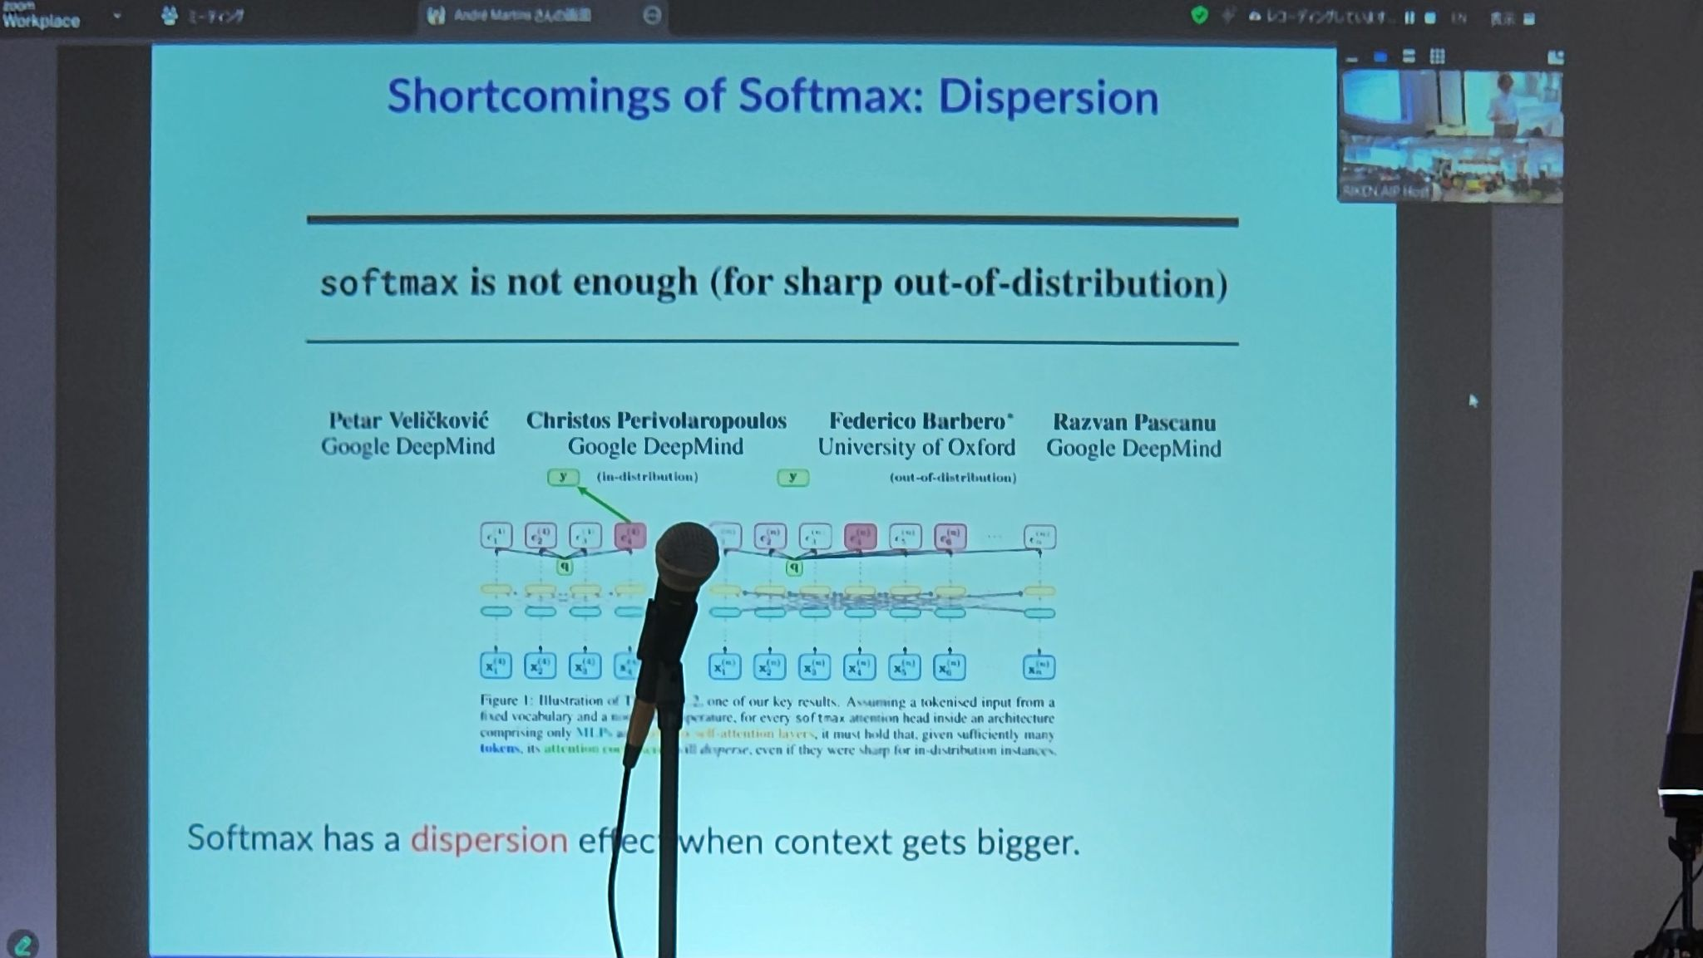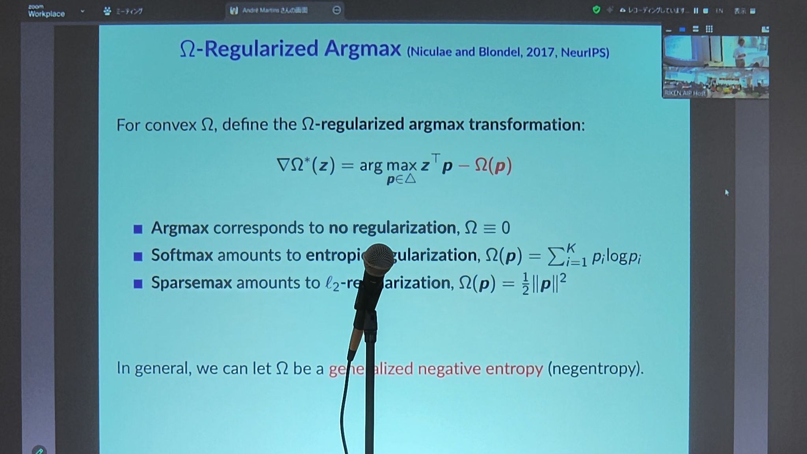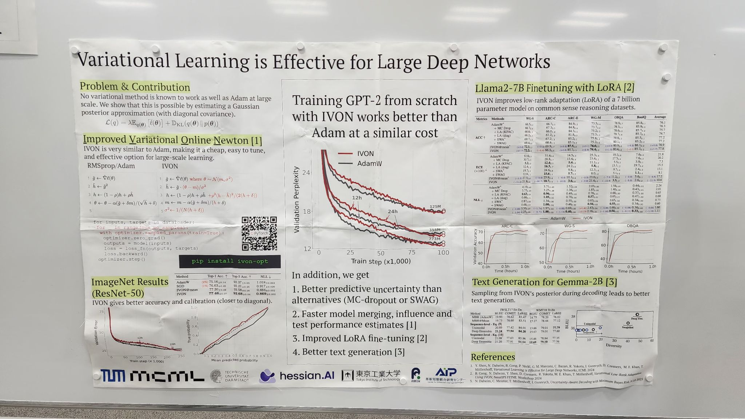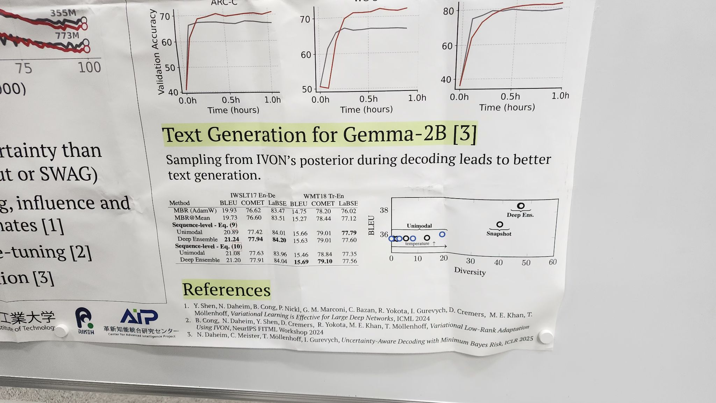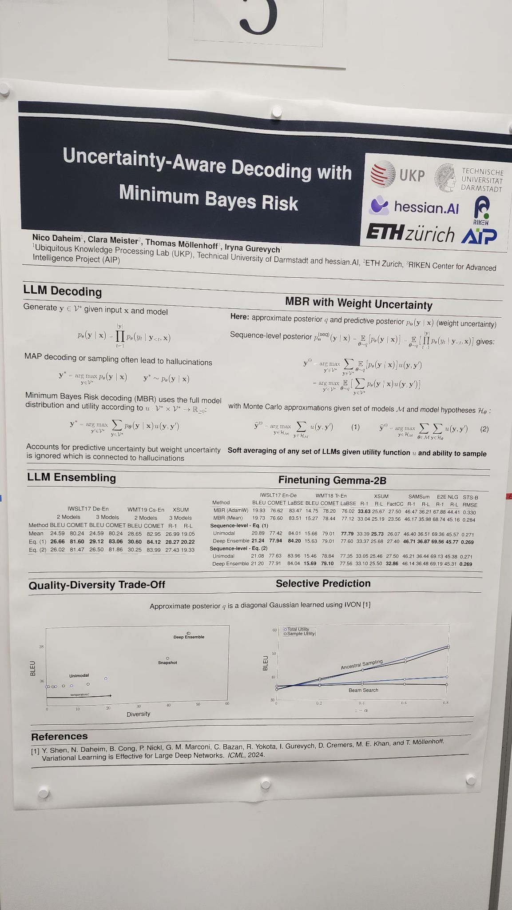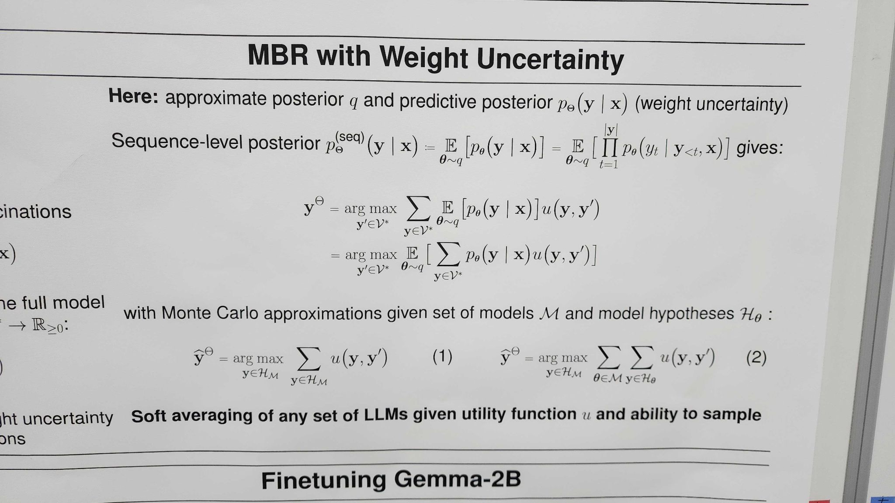/workshop_2025.html

ICML Workshop on Uncertainty (April 2025)
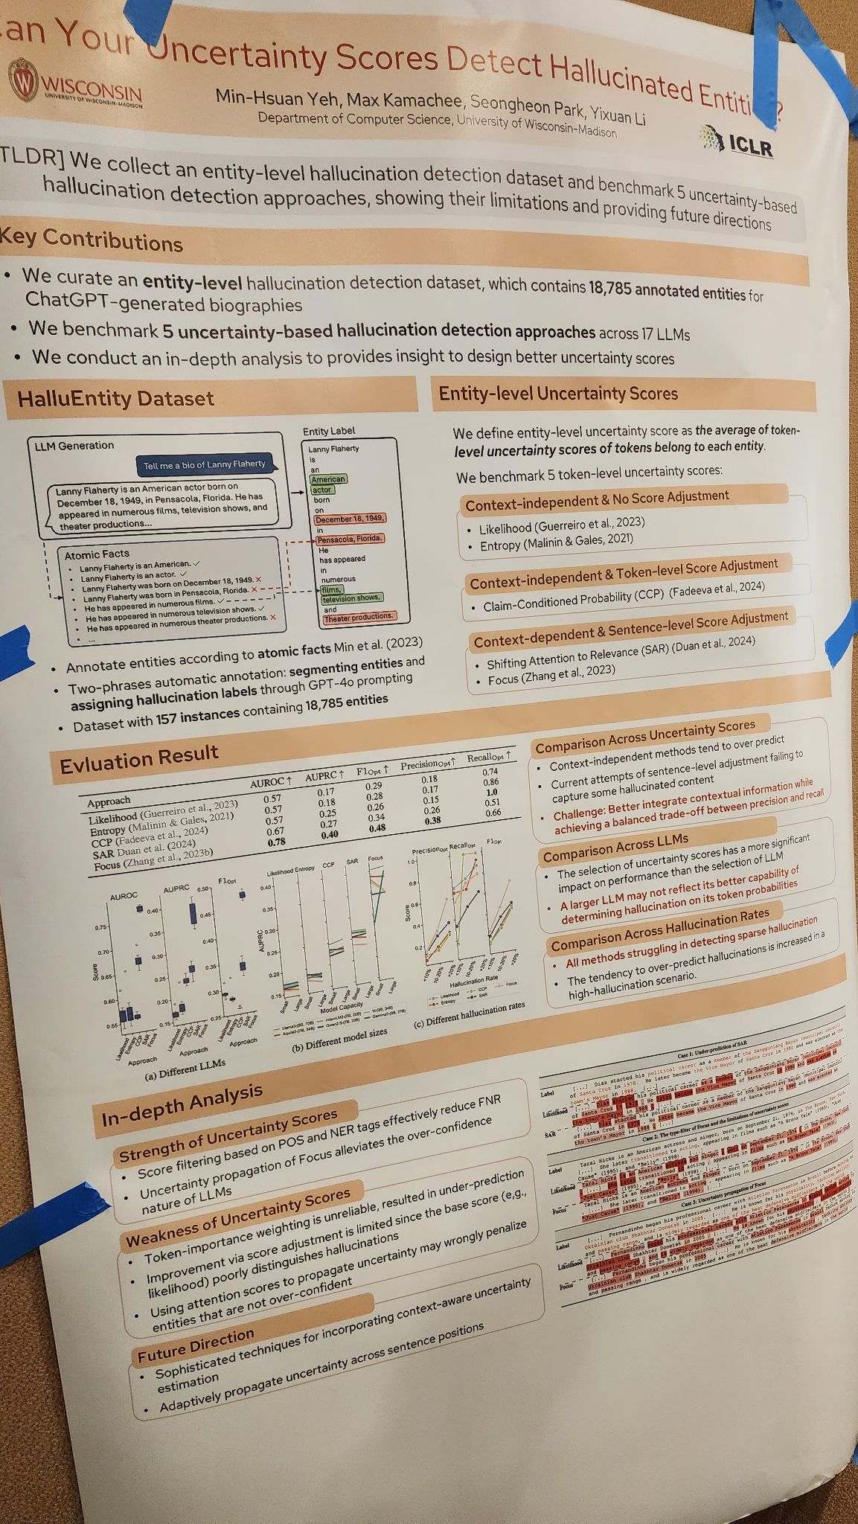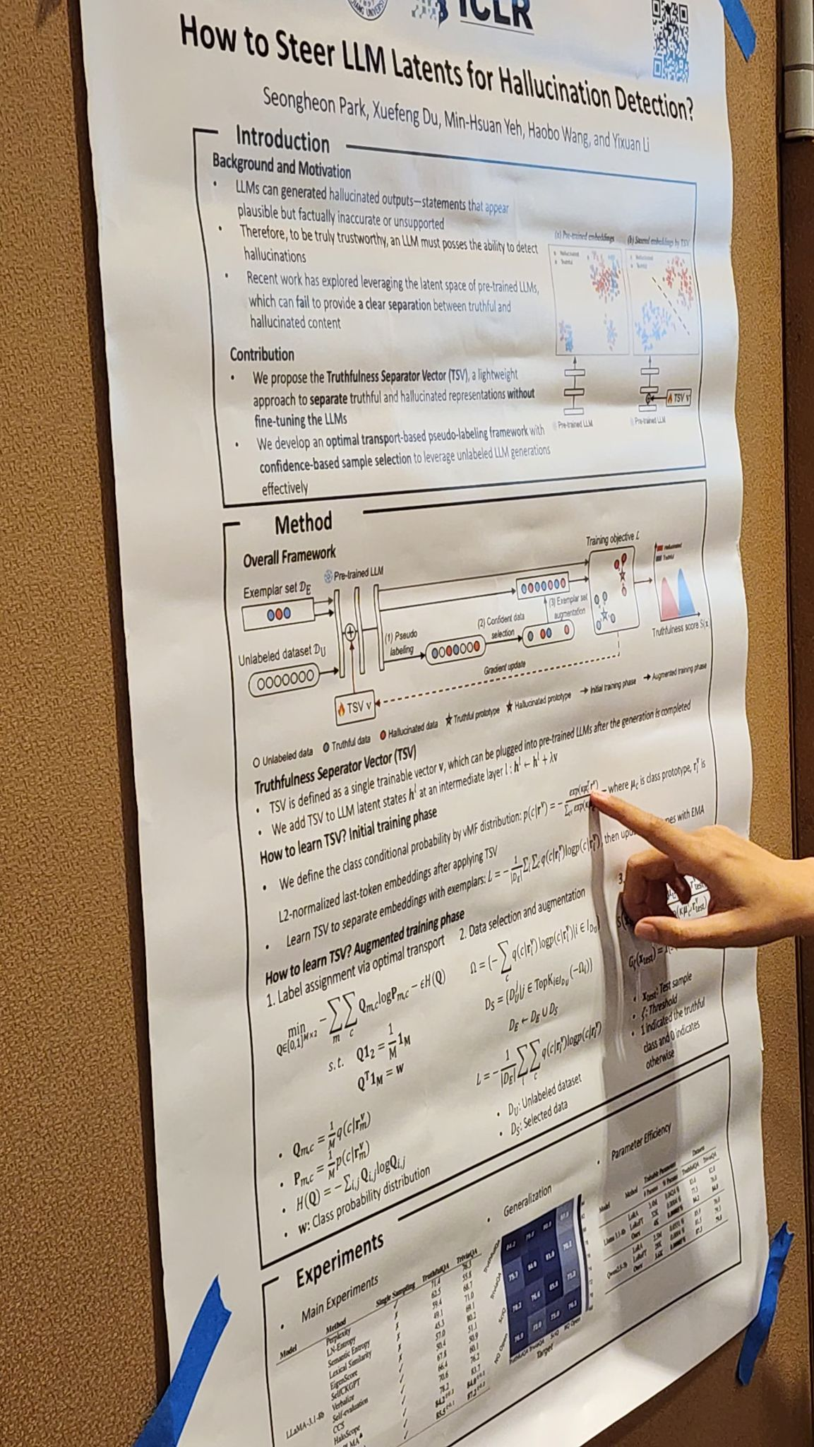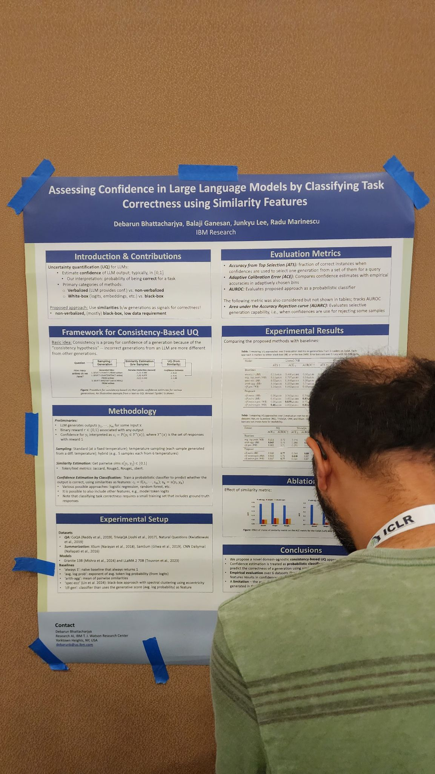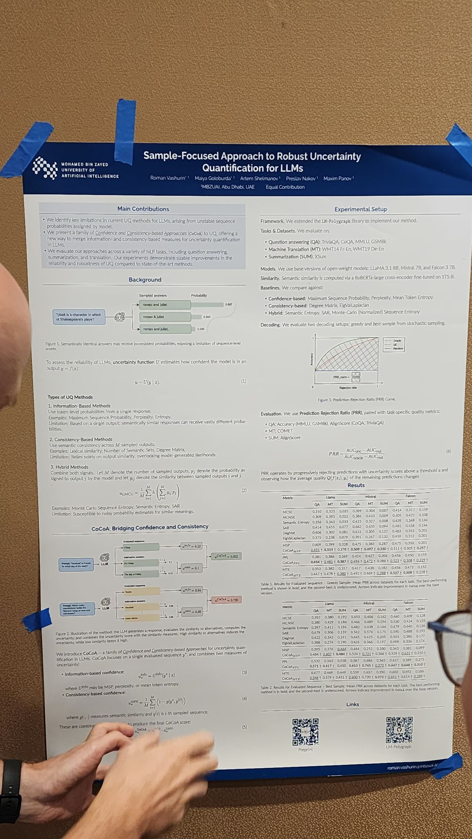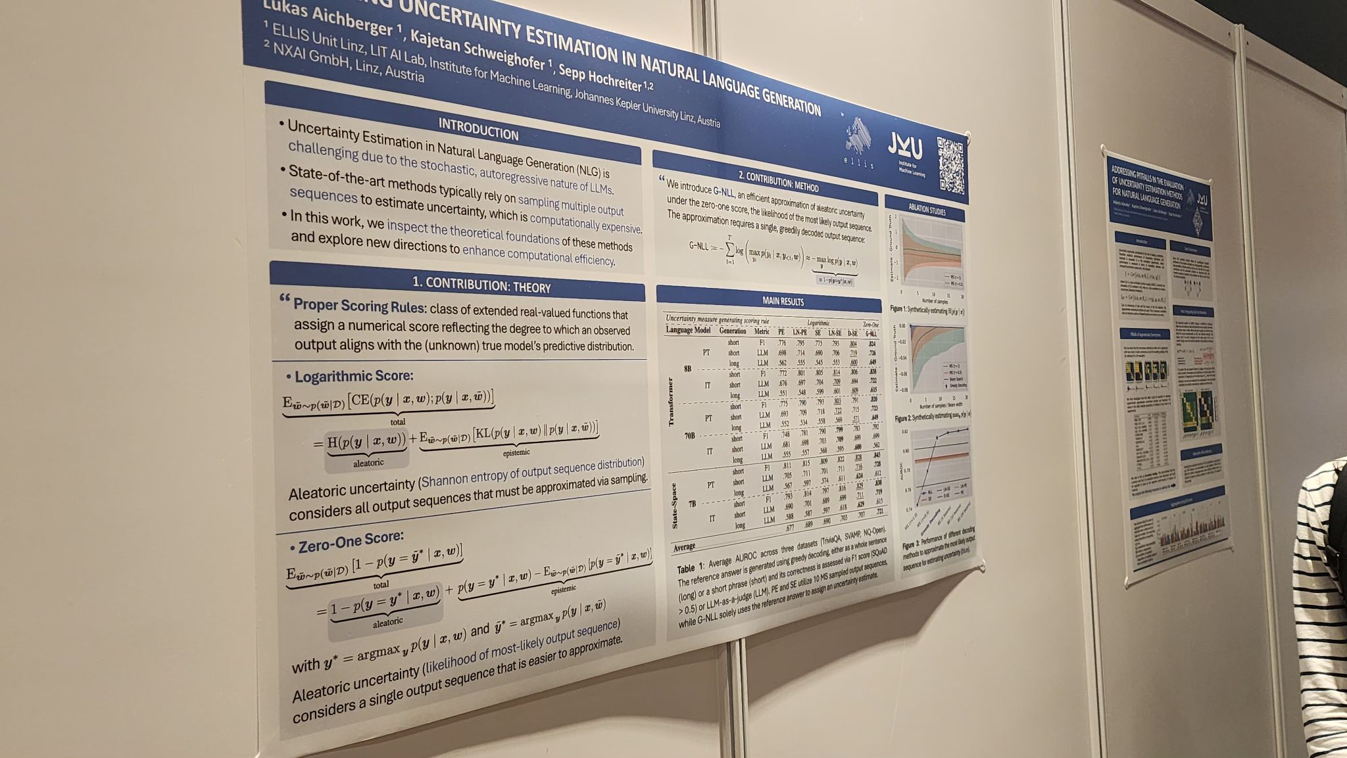

GitHub - IINemo/lm-polygraph: Uncertainty estimation for LLMs

2025-06-12: LLM Priors
- start preparing a pre-print
  - read https://arxiv.org/pdf/2505.11731 to see differences
- continue working on Laplace: first point-wise training and then Laplace. @Harsha if there's still problems - let me know, I will try to help or contact to a student that was able to run the code
- re-consider Entropy computation for ensembles and teacher (weighted probabilities vs weighted entropies vs differential entropy for Dirichlet)

2025-06-05: LLM Priors
- Push the code in the repository
- Let’s see confidence bars in our predictions:
  - run 5 times experiment (with different random initialization) for the prompt with the highest, average, the worst weight: report mean, median, std for F1 & ECE
  - run 5 times experiment (with different random initialization) for a fixed alpha_0 and report mean +/- std to see how stable are the results
    - plot ECE and F1 for a fixed alpha0: 0.001, 0.01, 0.1, 1.0, 10, 100, 1000, 10000
- Continue on Laplace-LoRA
- Tomasz: Think how to correctly compute the average entropy for Teacher and Student with Dirichlet outputs.

2025-06-02: LLM Priors:
> in the meeting you were saying that evaluation in Laplace-LoRA is performed by taking softmax of mean of logits (which is not correct) but in the original code: https://github.com/adamxyang/laplace-lora/blob/c59665ded44670d3e0d0d35d0e755302aed52e50/run_classification_bert_laplace.py#L577C1-L577C190
it is mean of softmaxes of logits (which is correct).
which code were you referring to/showing?

Harsha> Actually I am referring to the other repository which they have mentioned i.e. https://github.com/MaximeRobeyns/bayesian_lora

https://github.com/Harsha1969/BPE-KD/blob/main/train_student.ipynb

2025-05-29: LLM Priors:
- We need to understand better variance in predictions - let’s measure entropy on OOD data for all models (teacher, student softmax, student dirichlet)
- Laplace-Lora model is doing predictions in a weird way: it takes mean of logits and then pushes it through softmax instead of the other way around. Should we consider a different model?
- What would happen if we fixed \alpha_0 during TRAINIG? (last week’s 1b)
- What would happen if we tried to fit students using the prompts with the lowest / some average weights?

2025-05-27: LLM Priors
- Baseline Student approaches:
  - model with Softmax instead of Dirichilet
  - model with fixed \alpha_0. See the impact on the performance for varying values.
- Look into literature regarding:
  - distillation for generative problems
  - learning for LLMs with Dirichilet outputs (optional)
- Debug issues with Laplace-LoRA: compare output probability samples against BayesPE

2025-05-15: LLM Priors
https://www.perplexity.ai/search/in-generative-setting-models-c-DT9tuOvyQaGivRyM1.w7og
https://gemini.google.com/app/4e4a207ef7230135

- Add inference time to reports
- Perform distillation from Laplace-LoRA
- Test distillation from combination of teachers: Laplace-LoRA + BayesianPE. Two options
  - Combination of losses: Loss(sample) = p1 * Loss1(sample2) + (1-p1) * Loss2(sample)
  - Alternating sampling: select model ~ Bernoulli(p1), use only the loss for the selected model
  - Try pi=0.5, 0.2, 0.8 and report results
- Design an experiment explaining why using Dirichlet on student’s outputs gives us better results than from the original Teachers. Currently we do PEFT for training the student, can we do something like that also for the Teacher?
- For future: should we try to summarize the approach and make submission for a workshop/conference?
- For future: how to move towards generative tasks, i.e., how to perform distillation in generative tasks?
- one idea: sentence-level uncertainty quantification -> add loss component enforcing matching between Teacher’s score on sentence with the student’s.

Ideas for the Dirichlet experiment:

Fixed vs. Learnable α₀: Compare models where α₀ is fixed to a high value (reducing uncertainty) versus models where α₀ is learnable. Observing differences in overfitting and calibration can highlight the regularizing role of α₀.
Comparison with Softmax Outputs: Directly compare the performance of models using Dirichlet outputs versus traditional softmax outputs. Improvements in generalization and calibration in the Dirichlet model underscore its regularizing benefits.

Check if there are Generative models using Dirichlet distribution in output instead of softmax?:

2025-05-08 LLM Priors
- Laplace-Lora -> Harsha
- How we can do distillation of uncertainty for generative
  - https://arxiv.org/pdf/2412.15176 (Suggested by Srijith)

2025-04-17: LLM Priors
- can we add @Harsha to plgrid?
- add numbers for baseline with softmax if possible
- trying Bayesian LoRA (Laplace-LoRA with MC sampling or alternatively SWAG-LoRA) as teacher
- identify papers to evaluate generative tasks; identify if there are models with epistemic uncertainity for generative tasks aka “generative Prompt Ensembles”
- Play with concentration of Dirichlet distributions of an already pre-trained student network to see how this affects metrics e.g. ECE.

2025-03-27: LLM Priors
github: https://github.com/Harsha1969/BPE-KD

- update the repository with the recent modifications
- summarize the numbers in a doc - include the performance before any training
- test the code on more datasets to confirm the patterns we see:
  - ask them about Amazon dataset
  - try imdb, yelp
- consider the question whether we can extend the scope of applications beyond the simple classification; check the literature for a potential teacher with ability to detect e.g. hallucinations

From Harsha:
- I have mailed the authors regarding the datasets and CCed you both in that.
- I have updated the github repository with the recent modifications and it can be accessible through this link : https://github.com/Harsha1969/BPE-KD.git
- I have summarized the results on Amazon Reviews Polarity dataset in a table and kept that in a document and once I get the remaining datasets I will include results of those in the same doc. The document can be accessible through this link : https://docs.google.com/document/d/1rfn-j9_mQ8qs47WcdeC3WtraYFhKVKoRdoavOZzfBvU/edit?usp=sharing

2025-03-27: LLM Priors

- The teacher (Bayesian Prompt Ensemble) gives us a set of probability distributions + weights
- One option would be to average these distribution and get the expected Categorical distribution for which we could use equation (6) from [1] and then proceed using equation (9) form [1]
- Alternatively (what we would like to start with) is Ensemble Distillation: we consider each of the probability distributions from the teacher as a “data point” to which we fit MLE of the student’s Dirichlet parameters \alpha: eq (8) in [2]
- Eventually, we can also rescale \alpha-s of the student based on a separate criterion.
- \alpha-s are softplus values of the student’s network logits, which are trained implicitly e.g. when training parameters of the student’s network
- Explicitly we train the student’s network parameters using LoRA
- We want to also train the last layer in the student network as the meaning of the logits changes from softmax in the pretrained Categorical likelihood to softplus of the Dirichlet likelihood
- When distilling we can have additional MAP term for the objective for the student network. MAP terms relies on a Categorical likelihood whereas our student uses the Dirichlet likelihood. There are two ways of getting a Categorical likelihood from the Dirichlet likelihood:
  - use the expected Categorical distribution with probabilities p_k = \alpha_k / \alpha_0 - this option should be more stable during training (preferred)
  - sample Categorical distribution probabilities from Dirichlet e.g. p ~ Dirichlet(\alpha) - this option is more flexible.

[1] Beyond Dirichlet-based Models: When Bayesian Neural Networks Meet Evidential Deep Learning
[2] Ensemble Distribution Distillation

2025-03-24: Research: Distilling Bayesian LLM teacher into a Dirichlet student

https://www.perplexity.ai/search/why-for-dirichlet-networks-e-g-sYCuMJaoSFSM2TvS9cS9BA

https://chatgpt.com/g/g-p-67937e861d308191a0d25bf328d04c61-llmprior/c/67e10e1e-47b4-8008-ad1e-93b311a32200

https://claude.ai/chat/9993099c-54d6-41d0-839b-3e58263c5a2b

2025-03-13: LLM Priors
We proceed with two directions:
- continue with model distillation on open models so we can sample from softmax outputs
  - if we are using Bayesian Prompt Ensembles: check if weights between prompts vary much; use the one with the highest weight for the student input; as an ablation study: compare the prompt with the highest weight against the one with lowest weight
- ensembles of outputs at varying depth uncertainties as a way to get uncertainty
  - we can start to see if this is a sensible way of getting uncertainty
  - there’s a challenge with multiple passes needed to explore (sample) the whole space of possible outcomes, e.g., if there are multiple outputs, we don’t sample just from the last one, but we may also sample output at which depth should be selected as input for the next step
  - We can try a simplified approach and consider sequences generated at a certain depth.

2025-03-06: LLM Priors:
- start working on distillation of (Bayesian) LLMs
- formalize depth uncertainty for LLMs (e.g. for the autoregressive setting)

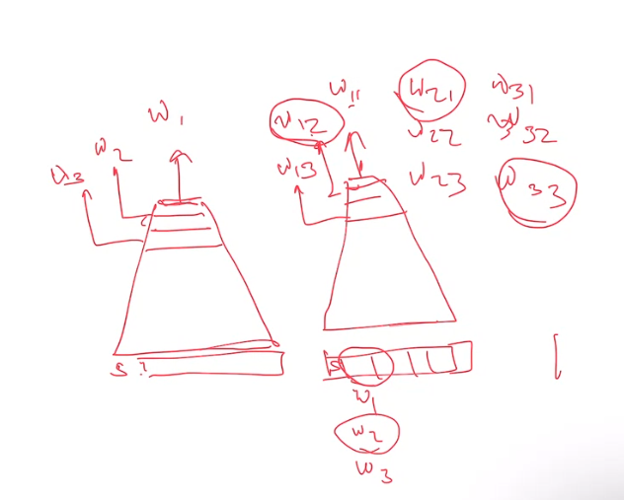

2025-01-24: LLM Priors (Srijith)

As discussed, I attach below, links to some papers which possibly may be relevant:

Fitting a model on top of LLMs:
- BIRD: A Trustworthy Bayesian Inference Framework for Large Language Models (https://arxiv.org/abs/2404.12494) -combines LLM-generated insights with Bayesian modeling
- Bayesian Concept Bottleneck Models with LLM Priors (https://arxiv.org/abs/2410.15555) - iteratively searches over a potentially infinite set of concepts, in which LLMs serve as both a concept extraction mechanism and prior
- Automated prior elicitation from large language models for Bayesian logistic regression (https://www.pure.ed.ac.uk/ws/portalfiles/portal/482094691/GoukAndGaoAutoML2024AutomatedPriorElicitation.pdf) - The knowledge they elicit from the LLM takes the form of synthetic training data. First, LLM is prompted to generate a batch of feature vectors and then to generate to generate target labels.
More prior eliciation:
- Eliciting the Priors of Large Language Models using Iterated In-Context Learning (https://arxiv.org/abs/2406.01860) - sampling prior from LLMs beliefs; similar and related to Deep de Finetti: Recovering Topic Distributions from Large Language Models (https://arxiv.org/abs/2312.14226) - both by Thomas L. Griffiths
Background paper:
- An Explanation of in-Context Learning As Implicit Bayesian Inference (https://arxiv.org/abs/2111.02080) - a "classic" paper from few years ago explaining how LLMs are implicit Bayesian models

Let me know if you think any of these are relevant or interesting, or if you have some others, I should take a look besides these mentioned in the presentation.

